INSTRUCTION PAGE FOR ENHANCED BIOSECURITY PLAN FOR FMD PREVENTION TEMPLATE WITH BLANKS
To be deleted
This document is a template to assist the Biosecurity Manager in developing an operation-specific, enhanced biosecurity plan for their feedlot. Each item from the Secure Beef Supply Plan Self-Assessment Checklist for Enhanced Biosecurity for FMD Prevention: Beef Feedlots is included. The Biosecurity Manager should keep all items that apply to the feedlot, modify them by replacing the (blanks) with information specific to the feedlot, and delete information that does not apply as well as all highlighted text. A labeled premises map must be included in this plan. Standard Operating Procedures (SOPs) may also be needed and should be available on the feedlot, but do NOT need to be included in this written biosecurity plan.

Enhanced Biosecurity Plan for FMD Prevention in
Date [Created or Updated]:
This Biosecurity Plan is based off of the Secure Beef Supply (SBS) Plan Self-Assessment Checklist for Enhanced Biosecurity, [May 2017] and was developed using guidance from the SBS Information Manual for Enhanced Biosecurity for FMD Prevention: Beef Feedlots. All documents are available at www.securebeef.org.

Scope of Biosecurity Plan
Describe the Premises:
- National Premises Identification Number (Prem ID or PIN): (request from the office of the State Animal Health Official)
- Premises Address:
- Premises GPS Coordinates:
- Animals on primary premises:
- Animal housing types:
- Other business operations on premises? If yes, what?
- Secondary premises* locations: (PIN, 911 addresses, or GPS coordinates):
  - Will be provided if this premises is located in an FMD Control Area

*Work with your State Animal Health Official to determine if separate PINs are needed for all of your associated premises
*Animals that are susceptible to FMD include cattle, pigs, sheep and goats. For biosecurity guidance for dairy cattle and pigs, see www.securemilksupply.org and www.securepork.org.
**Work with your State Animal Health Official to determine if separate PINs are needed for all of your associated premises.

Biosecurity Manager and Written Plan
The designated Biosecurity Manager for this premises and their contact information follows:
NAME:
PHONE:
EMAIL:
In the event the Biosecurity Manager is away from the operation, their designee’s contact information is:
NAME:
PHONE:
EMAIL:
The Biosecurity Manager’s contact information is posted .
and have the written authority to ensure compliance with biosecurity protocols and take corrective action as needed.
developed the operation-specific biosecurity plan with the assistance of (keep all that apply):
- , a licensed veterinarian whose contact information is:
PHONE:
EMAIL:

- , a consultant with whose contact information is:
NAME:
PHONE:
EMAIL:
The Biosecurity Manager or their designee (check all that apply):
☐ communicates with and/or trains individuals entering on biosecurity measures to follow;
☐ reviews the biosecurity plan at least annually and updates it whenever the feedlot goes through a change affecting biosecurity;
☐ ensures that all individuals entering the feedlot frequently (weekly or more often) have access to a copy of the biosecurity plan; and
☐ is capable of implementing the written plan if FMD is diagnosed in the U.S.
A labeled premises map is included at the end of this plan and can be found on the premises
at: .

Training
The people listed below are trained at least every about the biosecurity measures necessary to keep FMD out of the herd. This training is documented and available for review upon request.

The Biosecurity Manager(s) informs individuals entering the feedlot of the biosecurity measures they are to follow in a language they understand. Individuals are aware of the biosecurity concepts and procedures that apply to their specific areas of responsibility. Our required training is described below.
All individuals entering must understand how to
☐ Contact the Biosecurity Manager(s)
☐ Respect the Line of Separation (LOS)
☐ Cross the LOS, if required, following arrival and biosecure entry requirements
☐ Perform biosecurity measures for their specific job duties
Essential personnel must also:
☐ Understand the importance of biosecurity
☐ Review the entire biosecurity plan;
☐ Review the labeled premises map;
☐ Know who to report to if they see someone not complying or something preventing compliance; and
☐ Recognize the consequences for not complying with biosecurity protocols.

Protecting Feedlot Cattle

Line of Separation (LOS)
The Line of Separation is labeled on the premises map at the end of this plan. The LOS is marked on-site with .
Cattle do not have access to other livestock, streams, waterways, or run-off water or organic matter that may have come from other premises.

LOS Access Point(s)
Entry to the feedlot is restricted to controlled LOS Access Point(s) and each are labeled on the premises map at the end of this plan. The LOS Access Points are clearly marked with a suitable barrier of to restrict entry. Unused driveways that are not LOS Access Points are protected with to prevent vehicles and people from entering.
Signs written in languages are posted at all LOS Access Points that include .
All movements (animals, vehicles, equipment, people) across the LOS are recorded and these documents are kept in the and are available for review upon request.
The designated animal loading/unloading area is labeled on the premises map at the end of this plan and this is NOT used for a people entry point.
Deliveries not essential to the feedlot are made outside of the LOS at the and this area is indicated on the premises map and signage posted at the LOS Access Point.
Vehicles crossing through the LOS Access Points are cleaned to remove visible contamination and then disinfected at the Cleaning and Disinfection Station.
People and items crossing through the LOS Access Points follow appropriate specific biosecurity steps, described under Biosecure Entry Procedure in this plan.

Cleaning and Disinfection (C&D) Station
There is an operational, clearly marked, and equipped C&D station(s) located and it is labeled on the premises map at the end of this plan. The wash pad for the C&D station is made of and slopes away from animal housing, feed receiving or storage areas, waterways, and on-farm traffic areas. This feedlot uses to manage effluent from the C&D area to ensure susceptible animals are not exposed. Effluent from the C&D Station is managed following all state and local regulations.
This operation has access to all the equipment and supplies needed to successfully operate the C&D Station. The SOP for the C&D process is available upon request.
The following individuals have received documented training in proper selection and use of personal protective equipment, the principles of C&D to avoid introducing FMD virus to the operation, and area able to effectively operate the C&D Station.

In the case of inclement weather (freezing temperatures, thunderstorms, high winds) when the C&D Station cannot be operated, we have the following contingency plans to ensure vehicles do not bring visible contamination onto our feedlot:
- .

Designated Parking Area
The designated parking area is clearly marked with and labeled on the premises map at the end of this plan. It is located outside of the LOS and away from animal areas.

Vehicles and Equipment

Vehicles and Equipment (non-animal transport)
All vehicles and equipment (not containing live animals) are cleaned to remove visible contamination and effectively disinfected prior to crossing the LOS; otherwise entry is prohibited.

Livestock Trucks/Trailers (animal transport vehicles)
All empty animal transport vehicles are cleaned and disinfected prior to arrival at the feedlot (outgoing loads) or before animals are loaded for delivery to the feedlot (incoming loads).
Occupied animal transport vehicles are not allowed to cross the LOS. (Pick one, delete the other)
☐ Gates are installed to safely move livestock onto the operation from the livestock trailer.
☐ On-farm livestock trailers are used to transport animals to or away from the arriving livestock trailer at a designated cattle crossing LOS Access Point.

Harvest and Feed Delivery Equipment (pick one, delete the other)
☐ Freshly harvested crops are not delivered to this operation; OR
☐ A plan is in place to temporarily modify the LOS to create a direct path to the feed storage area for harvest vehicles/equipment that may be transporting feedstuffs during harvest of . This route is NOT used by vehicles inside the LOS to feed or contact animals. We are able to access this feed storage area from another direction that does NOT cross paths. Visible material on tires/undercarriage will be removed prior to entering the premises, with every effort made to not spray the feedstuffs (hay, silage, grain) carried by the vehicle. Once visible material has been removed, the harvest vehicles/equipment drive directly to the feed storage area. The drive path is cleaned and disinfected after harvest/feed delivery is complete, ensuring run-off/effluent does not enter animal housing, waterways, or traffic areas within the LOS. Once the area is C&Ded, the LOS is re-established as it was prior to harvest.

Personnel

Prior to Arriving at the Feedlot
The Biosecurity Manager ensure that everyone crossing the LOS on foot or exiting their vehicle inside the LOS has been instructed to arrive at the feedlot
- with a clean vehicle interior (free of all animal manure/excrement) that has not become contaminated by soiled clothes, footwear, or other items,
- having showered and wearing clean clothing and footwear since last contacting susceptible animals.
  - For individuals that work with animals and live on-site, showering and changing into clean clothing/footwear before leaving the house is required.
  - For individuals living off-site, after showering and changing into clean clothes and footwear, they must NOT contact animals, live or dead, or facilities where they are held prior to arrival at the feedlot.
Essential personnel who will need to cross the LOS during an FMD outbreak include:

These individuals have a signed Employee and Visitor Arrival Agreement on file agreeing to follow our biosecure entry procedures (described below).

Entry Logbook
Everyone crossing the LOS Access Point(s) completes the entry logbook, which is located , unless they are a scheduled worker.
The entry logbook is monitored by on the feedlot to ensure accurate completion.
The contact information and work schedule records for all workers are maintained and posted .

Biosecure Entry Procedure
All individuals crossing the LOS on this feedlot must:
- Ensure that the inside of their vehicle is clean (free of all animal manure/excrement) prior to arrival and has not become contaminated by soiled clothes, footwear, or other items.
- Ensure they have showered and changed into clean clothes and footwear prior to arrival on the feedlot.
  - For individuals that work with the animals and live on-site, showering and changing into clean clothing/footwear before leaving the house is required.
  - For individuals living off-site, after showering and changing into clean clothes and footwear, they must NOT contact animals, live or dead, or facilities where they are held prior to arrival at the feedlot.
☐ Put on feedlot-dedicated clothing and footwear at the LOS Access Point, OR
☐ Put on clean coveralls/protective outerwear and disposable or disinfectable footwear at the LOS Access Point or when they exit their vehicle on the cattle side of the LOS; AND
- Ensure hands are clean
All non-animal handlers and those remaining away from animal areas on this feedlot must:
☐ Wear feedlot dedicated footwear, OR
☐ Wear disposable or disinfectable footwear; AND
- Ensure hands are clean
  - Wash hands and/or wear disposable or disinfectable gloves over clean hands
Biosecure Exit Procedure
Individuals crossing the LOS to the non-cattle side must exit through the and remove protective outerwear, disposable footwear, and gloves.
Hands may be washed .
The procedure for soiled clothing is .
The procedure for soiled footwear is .

Animal Movement

Incoming Animals
Animals come only from sources with documented biosecurity practices that align with this feedlot’s biosecurity practices. The animal caretakers on the farms of origin are trained to look for signs of FMD. The incoming animals have no current or previous evidence of FMD infection.

Pre-movement Isolation Period
(Pick one, delete the other)
☐ We do not accept animals from operations within an FMD Control Area.
OR
☐ We only accept animals from an operation in the FMD Control Area that have not received any animals from another production site with susceptible animals for at least .

Contingency Plan for Interrupted Animal Movement
In the event animal movement is stopped for several weeks, this is our plan for managing animals in a biosecure manner: (keep and modify all applicable statements, delete the others)
☐ Cull cattle will be humanely euthanized and properly disposed of on the operation (described under Carcass Disposal below).
☐ Housing, feed, and healthcare equipment is available for of slaughter-ready cattle for a period of . A contingency plan has been established for ration formulation, transport and market of cattle that are at, approaching, or have exceeded market weight.
☐ All calves born on the feedlot (from heifer-raisers, or unintentional breeding) can be housed, fed, and cared for in an outbreak. Describe your plan to manage these animals:
☐ There is enough housing, feed, and feeding equipment available for of calves for a period of .
☐ We plan to obtain calf housing and feeding equipment from to house/feed calves if we are unable to move off-site.
☐ Personnel trained in pre-weaned calf husbandry are available.

Loading/Unloading Animals
Animals arriving at or leaving the feedlot only move in one direction across the LOS at an Access Point labeled on the premises map at the end of this plan. The animal loading/unloading area is NOT a people entry point. All areas inside the LOS that become contaminated by personnel or animals loading are cleaned and effectively disinfected by trained personnel after loading is complete. The SOP for the C&D process is available upon request.
The following individuals have received documented training in proper selection and use of personal protective equipment, the principles of C&D to avoid introducing FMD virus to the operation, and are able to effectively C&D the loading area:

Animal Products

Semen, Embryos (pick one, modify/delete the other)
☐ This feedlot does not introduce semen or embryos from off-site locations.
OR
☐ The Biosecurity Manager will ensure that any semen or embryos collected after FMD has been diagnosed in the U.S. and introduced to this feedlot come only from sources with documented, enhanced biosecurity practices and have no current or previous evidence of FMD infection.
- Semen and embryos must be held and frozen at the source herd for 14 days after collection, and animals re-evaluated for signs of FMD after the 14 days before shipping.
- Semen and embryos are transported in containers whose exteriors can be cleaned and effectively disinfected as it crosses the LOS
- The source herd must document Active Observational Surveillance for at least 14 days prior to movement of product.

Feeding Dairy Products (pick one, delete the other)
Cattle on the operation:
☐ Are fed dairy products (e.g., whey) that have been treated to OIE recommendation for inactivation of FMD virus for animal consumption.
OR
☐ Are not fed dairy products.

Carcass Disposal
In an FMD outbreak, dead animals are disposed of by which prevents the attraction of wildlife, rodents, and other scavengers, and is in accordance with state and federal laws
☐ Rendering trucks and other vehicles hauling dead animals to a common disposal site do not cross the LOS.
☐ Routes for carcass movement and disposal are labeled on the premises map at the end of this plan.
The disposal method utilized on the feedlot is.

Manure Management
The procedure for manure storage is .
In the event of a prolonged outbreak, we can store manure for . After that time, the method for manure removal is . This will prevent exposure of susceptible animals and meet state, local and Responsible Regulatory Officials regulations.
(Pick one, modify, delete the other)
☐ Operation-specific dedicated manure handling equipment is used and equipment is not shared with other operations unless absolutely necessary
OR
☐ All manure handling vehicles and equipment from other sites must be cleaned to remove all manure and disinfected with either heat or a chemical disinfectant followed by drying. All manure handling personnel must have showered and changed into clean clothes and footwear prior to arriving at the operation. These expectations have been communicated to contract companies, and signed and dated when read. This communication is kept on file here: . In the event that manure handling equipment from another location cannot be effectively C&D, a plan to temporarily modify the LOS near the manure storage facility during manure removal is in place. The affected areas are cleaned and disinfected before returning to the original LOS.

Rodent, Wildlife and Other Animal Control
The following control measures are in place to minimize interaction between cattle and other animals (deer, feral pigs, rodents, dogs, cats, etc.)
(pick one of the following, modify, delete the other)
☐ This operation utilizes to discourage rodents. Bait is checked every by and replaced as needed. This protocol is in accordance with state and local regulations for controlling rodents.
OR
☐ This premises works with a professional rodent company, , and has documented procedures which are located describing the frequency and observations by the company representative. This protocol is in accordance with state and local regulations for controlling rodents.

Mark those that apply, provide details where requested)
☐ Weeding and grass control is done every .
☐ The sanitation of general office areas is completed every .
☐ Trash is removed every . In an outbreak, crossing of the LOS by the garbage truck is .
☐ Feed spills are cleaned up immediately by .
☐ Measures to prevent wildlife access to livestock on this operation include .
☐ Dogs, cats, and other pets are NOT allowed to roam between operations during an outbreak.
OR
☐ There are no dogs or cats on this operation.

Feed
Grain and feed commodities are delivered in trailers that are covered during transport.
In an outbreak, feed trucks delivering feedstuffs or finished feed would
☐ Cross the LOS through an LOS Access Point
☐ Auger feed across the LOS into a farm vehicle/feed wagon located on-site.
Feed spills are cleaned up as soon as possible to minimize attraction of wildlife and rodents.

Labeled Premises Map
Guidance for creating a premises map (satellite images are preferable) can be found in Appendix A of the SBS Information Manual for Enhanced Biosecurity for FMD Prevention: Feedlots.
Premises Address:
PIN:
Label your premises map with the following:
Public road
Line of Separation (LOS)
LOS Access Point
Vehicle cleaning and disinfection (C&D) station(s)
Designated parking area
Loading site
Carcass disposal/pickup location
Carcass removal pathways
Deliveries (non-essential to the feedlot)
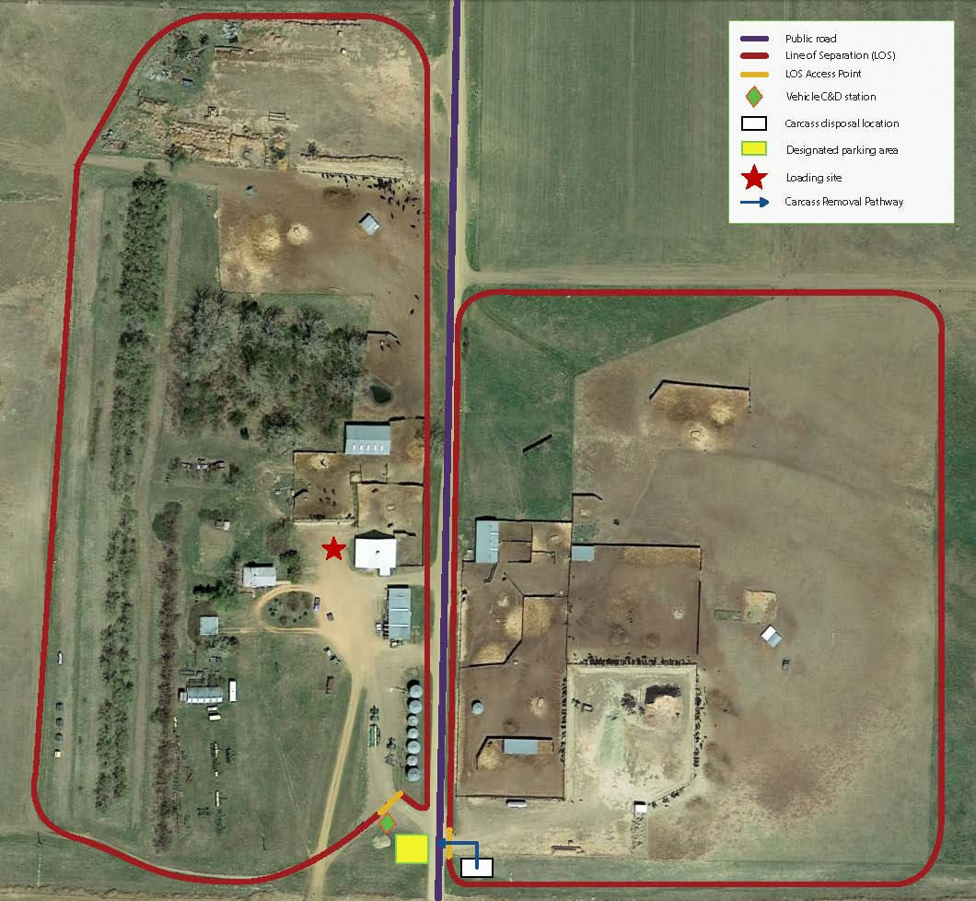
EXAMPLE: Replace with your feedlot’s premises map

