Example Preventive Control Program

Some City Feed Mill

Other Preventive Control for Aflatoxin

A. Purpose
Mycotoxins would have a moderate severity overall. Aflatoxin, deoxynilvalenol, and fumonisin may be hazardous to the health of swine, poultry, equine, beef, dairy, sheep, or goats that are intended to consume our feed, and are capable of causing large quantities of animal illness or deaths. Aflatoxin has the potential impact to human health because it can be passed to humans through their consumption of animal products like milk. Aflatoxin currently has a moderate probability of occurrence in corn gluten feed and its storage within the facility, so it is a hazard requiring a preventive control. The intent of this preventive control is to significantly minimize or reduce the probability of aflatoxin in finished feed.

B. Responsibilities
The owner, operator, or agent-in-charge of the facility and the Preventive Controls Qualified Individual have determined that this preventive control is necessary to reduce the occurrence of aflatoxin. The Mill Manager is responsible for its implementation by all parties. Qualified individuals involved in manufacturing, processing, packing, or holding ingredients and feed are responsible for implementing these activities as appropriate for their roles. Specifically, the Scale House and Receiving Operators have responsibilities for this program’s implementation.

C. Actions and documentation to control mycotoxins

1. Monitoring.
- The only approved supplier for corn gluten feed is Company M. Upon arrival at the facility scale house, a bill of lading accompanying the ingredient must be reviewed by the Scale House Operator to confirm that the ingredient name is corn gluten feed, the supplier is Company M, and the destination is Some City Feed Mill. Deliveries of corn gluten feed that do not have a bill of lading that specify this information will be rejected by the Scale House Operator.
- If the bill of lading is satisfactory, the Scale House Operator will insert the autoprobe ten different times in a double X pattern (picture below) to collect ten individual 1-lb samples from each trailer (total of 10 lbs collected). The autoprobe is set to collect samples from varying depths throughout each probe. If the autoprobe is not functioning, the load must be manually probed ten times in a double X pattern with the hand probe located in the Scale House to collect a total of 10 lbs. of sample.

- The ten samples from the autoprobe will be combined and hand-mixed. The entire sample will be weighed on a certified scale to confirm that at least 10.0 lb. were collected. Additional probes are to be collected using the double X pattern, if necessary, to reach this minimum mass.
  - The sample will be evaluated for color and texture to confirm that it matches that of the check sample located in the Scale House. It will also be evaluated to ensure it is free of visual contamination. Any variation will result in the sample being rejected by the Scale House Operator.
- The entire 10 lb. sample will be ground and sifted through a No. 20 mesh screen.
- The 10 lb. ground sample will be reduced to a representative 10 g sample (+/- 0.1 g) using a riffle divider.
- Analyze the resulting 10 g sample total Aflatoxin using the Reveal® Q+ for Aflatoxin test strips in the AccuScan® Gold Reader using the following method as directed by Neogen in their FGIS-approved method in our internal laboratory in the Scale House:
  - To the 10 g sample, add 50 mL of 65% ethanol in a sample cup with screw-on lid.
  - Shake the sample for 3 minutes using the timer to ensure shaking occurs for a long enough period of time.
  - Allow the sample to settle for 1 minute.
  - Poor the liquid portion through a filter so at least 3 mL of fitered liquid is collected.
  - Use a clean pipette to obtain 100 µL of the sample liquid, place it in the red dilution cup, and homogenize by pipetting up and down 5 times.
  - Use a clean pipette tip to obtain 500 µL of sample diluent to the red dilution cup.
  - Use a clean pipette tip to transfer 100 µL of the diluted sample extract to a clean sample cup.
  - Confirm the test strips are within their expiration date and place a new test strip in the sample cup for 6 minutes using the timer.
  - Remove the test strip from the cup and place in the reader. The range of this testing method is 3 to 100 ppb of total aflatoxins (Aflatoxin B₁, B₂, G₁, and G₂). The target parameter value of 20 ppb aflatoxin.
  - The result must be documented in the Mycotoxin Log, which is located in the Scale House. These records will be maintained for 2 years.

2. Corrective Actions
- Based on the results of the aflatoxin testing of corn gluten feed, the following actions are to occur:
  - < 5 ppb aflatoxin: The load will be received with no further action.
  - 5.0 to 19.9 ppb aflatoxin: The load will be received but further action is required. All diets containing corn gluten feed over the next 14 days will be analyzed for aflatoxin. At least ten samples will be collected at the port located at the mixer discharge to create a total volume of 10 lbs. per batch of feed. Monitoring steps 4-6 will be completed to analyze the complete feed for total aflatoxin. Feed intended for swine, poultry, equine, beef, dairy, sheep, or goats must test 19.9 ppb aflatoxin or less to be released for distribution. If It tests 20.0 ppb or above, the feed must be safely diverted to finishing beef cattle (up to 300 ppb) or finishing swine (up to 200 ppb) or disposed of in a landfill with documentation of destruction.
  - 20.0 ppb aflatoxin or above: The load will be rejected.
- If a load is rejected, regardless of the reasoning, the Scale House Operator will notify the Mill Manager via e-mail. The Mill Manager will then notify the Procurement Department and the PCQI that rejection occurred, including the justification for the rejection so it can be considered in future contracting of approved suppliers and in the hazard analysis/food safety plan. The PCQI will lead an investigation to identify and correct the problem, as well as prevent its reoccurrence. Records of these decisions will be maintained by the PCQI.

3. Validation
- The following are actionable levels from the FDA Compliance Policy Guide Sec. 683.100 Action Levels for Aflatoxins in Animal Food dated March 2019:
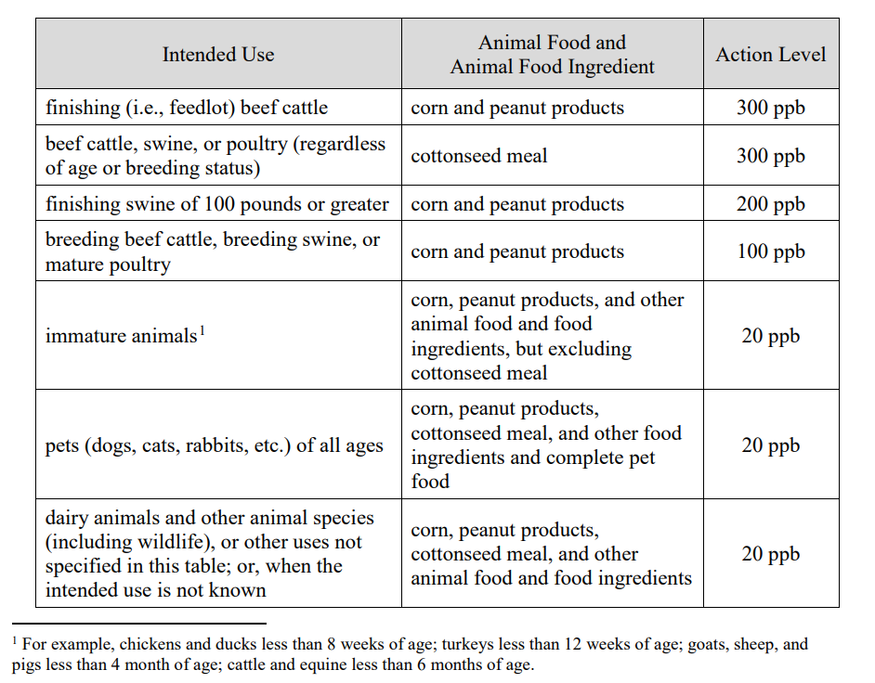

4. Verification
- Monitoring and corrective action records must be reviewed within 7 days of creation.
- Scales used for weighing samples for analysis must be calibrated. A check weight of 10.0 lb or 10 g will be used for the respective scale prior to each use to confirm its accuracy. Scales will be certified by an outside party annually. Records of this will be reviewed within 7 days of creation.
- Product testing requirements are described in the Monitoring Steps 2-6.

D. Mycotoxin Log

Mycotoxin Log for Some City Feed Mill, 123 First Avenue, Some City, KS, 00000
Date and Time  of Analysis | Ingredient  Type | Ingredient Supplier | Tested Level | Product Used or Rejected? | Notes | Initials
1/4/2021  8:46 AM | Corn Gluten Feed | Company M | Aflatoxin:18 ppb | Used | Finished feed samples collected through 1/18/21 | TPB
1/7/2021  10:19 AM | Corn Gluten Feed | Company O | n/a | Rejected | Vendor not approved | TPB
1/7/2021  2:25 PM | Corn Gluten Feed | Company M | Aflatoxin:26 ppb | Rejected | n/a | TPB
1/8/2021  9:46 AM | Beef breeding feed with corn gluten feed | n/a | Aflatoxin:4 ppb | Approved for Distribution | n/a | TPB
1/8/2021  11:24 AM | Corn Gluten Feed | Company M | Aflatoxin:16 ppb | Used | Finished feed samples collected through 1/22/21 | TPB

