Plant Protection and Weed Control Program Staff

Kansas Department of Agriculture
1320 Research Park Drive

Manhattan, Kansas 66502
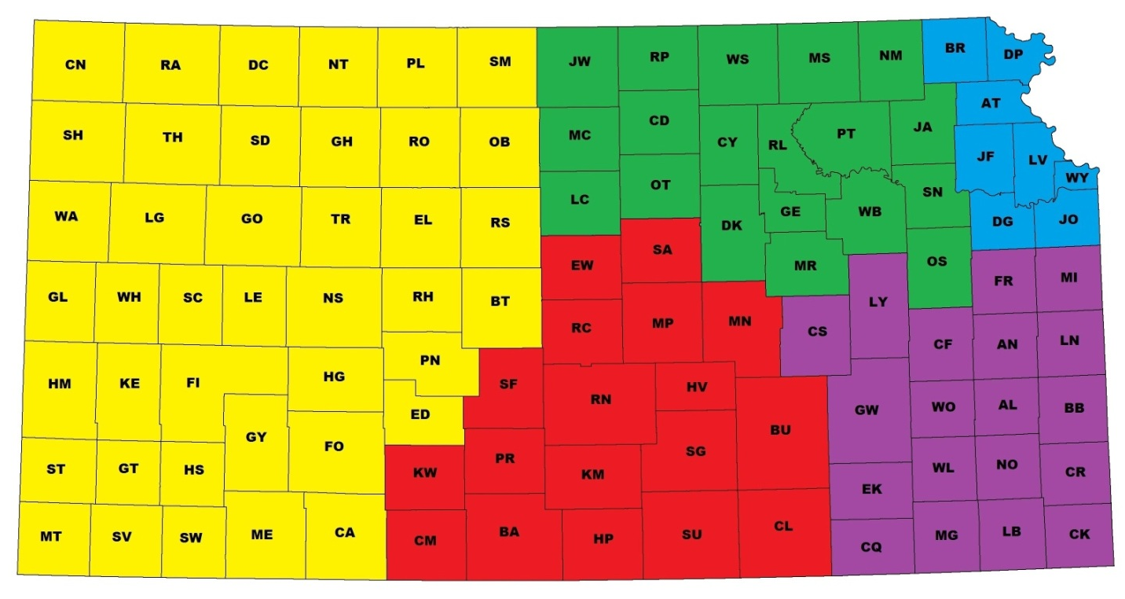
Area Field Staff

West – Bob Buhler: 785-207-1507 bob.buhler@kda.ks.gov

South Central – Cherie Copeland: 785-207-0580 cherie.copeland@kda.ks.gov

Northeast – Tom Sanders: 785-207-0582 tom.sanders@kda.ks.gov

Southeast – Jeremy Maples: 785-256-3849 jeremy.maples@kda.ks.gov

Kansas City Metro – Jennifer Smith: 785-213-6890 jennifer.smith@kda.ks.gov

Administrative Office (Manhattan)
785-564-6698

Program Manager: Jeff Vogel – jeff.vogel@kda.ks.gov

Administrative Assistant: Evelyn Musick – evelyn.musick@kda.ks.gov

Weed Specialist: Scott Marsh – scott.marsh@kda.ks.gov

Plant Pathology: vacant

Field Office (Topeka)
6531 SE Forbes Avenue, Suite B
Topeka, Kansas66619
785-564-6698

Entomology: Greg Chrislip – greg.chrislip@kda.ks.gov

CAPS Coordinator: Laurinda Ramonda – laurinda.ramonda@kda.ks.gov

