Floodplain Mapping Open House
Social Media Plan

Communication goals
- Promote meeting attendance at upcoming open house; and
- Increase baseline understanding and awareness of open house topics.
Social media best practices
- Facebook- Ideal for raising awareness and communicating with stakeholders and is the number-one platform for video sharing
  - Post one to two times daily.
  - Thursdays and Fridays are generally best for engagement.
- X (formerly known as Twitter) - Great tool for news and customer service so use for real-time updates.
  - Until recently, each post was limited to 280 characters. While more can be used now, short posts are still advised.
  - Post at least daily and up to six times daily.
  - Wednesday, Saturday, and Sunday are the best days for posting.
  - X is a high-volume channel so posts have a short life cycle—around 18 minutes.

Editorial Calendar
Date | Primary Content Theme | Platform | Post Draft | Image (Link)
Day 1 | Meeting attendance | Facebook | Save the date! COMMUNITY and the Kansas Department of Agriculture (KDA) will host a public Open House to discuss the draft Flood Insurance Rate Map (FIRM) on DATE, from 2-6:30 pm at the LOCATION. Chat with local flood experts to learn about the impact on YOUR property. | At This Meeting Poster
 | Meeting attendance | X | Save the date: Open House on DATE to chat about draft flood maps. | At This Meeting Poster
Day 7 | Understanding and awareness | Facebook | Anywhere it rains, it can flood. The extent of flooding can vary from neighborhood to neighborhood and even property to property. Chat one-on-one with flood experts about how local flood hazards have changed at the Open House on DATE, from 2-6:30 pm at the LOCATION. | But It Never Floods Poster
 | Understanding and awareness | X | Did You Know: Where it rains, it can flood. Chat 1-on-1 with flood experts on DATE from 2-6:30 pm at the LOCATION. | But It Never Floods Poster
Day 12 | Meeting attendance | Facebook | #DYK: COMMUNITY has a new draft Flood Insurance Rate Map? Our flood experts will tell you what that means and how it affects you at the Open House on DATE, from 2-6:30 pm the LOCATION. | Flooded Street
 | Meeting attendance | X | What’s a Flood Insurance Rate Map? Hear how the new one affects you DATE from 2-6:30 pm at the LOCATION.
Day 13 | Meeting attendance | X | Is your calendar marked for DATE? Chat w/experts about your #FloodRisk from 2-6:30 pm at the LOCATION.
Day 14 | Understanding and awareness | Facebook | Flooding is the most frequent and expensive type of natural disaster in our area. Learn more about the new flood maps and your property’s risk at a #FloodRisk Open House on DATE, from 2-6:30 pm at the LOCATION. | Insurance Adjuster Image
 | Understanding and awareness | X | Here’s your chance to have a 1-on-1 w/experts about your #FloodRisk. Join us from 2-6:30 pm at the LOCATION on DATE. | Meeting Image
Day 17 | Meeting attendance | Facebook | What’s your flood risk? Join the COMMUNITY officials, the Kansas Department of Agriculture, and FEMA for a #FloodRisk Open House tomorrow at the LOCATION from 2-6:30 pm to learn more about the new flood maps for our area. | Flood sign image
 | Meeting attendance | X  (AM) | What’s your #FloodRisk? Come to the Open House tomorrow at the LOCATION from 2-6:30 pm to find out! | Flood sign image
 | Understanding and awareness | X  (PM) | #DYK: Our last Flood Insurance Rate Map was updated over a quarter-century ago! | FEMA Conversation
Day 18 | Understanding and awareness | Facebook (AM) | Not-so-fun fact: Did you know that your home is five times more likely to flood than be damaged by fire over the next 30 years? Learn more about your flood risk and check out the new draft maps for our area by joining us for an Open House tonight from 2-6:30 pm at the LOCATION. | Flood Damage Poster
 | Meeting attendance | Twitter (AM) | #DYK: Flooding is the most frequent and expensive natural disaster in our area. | Flood Damage Poster
 | Meeting attendance | Twitter (AM) | What’s your flood risk? Come to the Open House TONIGHT at the LOCATION from 2-6:30 pm to find out!
 | Meeting attendance | Facebook | Tonight, join COMMUNITY and the Kansas Department of Agriculture (KDA) for a public Open House on the draft Flood Insurance Rate Map (FIRM) from 2-6:30 pm. Chat with local flood experts to learn how the new maps will have an impact on YOUR property. | At This Meeting Poster
 | Understanding and awareness | Twitter (PM) | #DYK: 1/3 of the recipients for flood-related disaster assistance are in low to moderate risk areas? | Disaster Assistance Image
 | Meeting attendance | Twitter (PM) | Tonight’s Open House starts now! It’s not too late to join us at the LOCATION to learn about your #FloodRisk! | Flooded Street

Image Appendices

FEMA Conversation
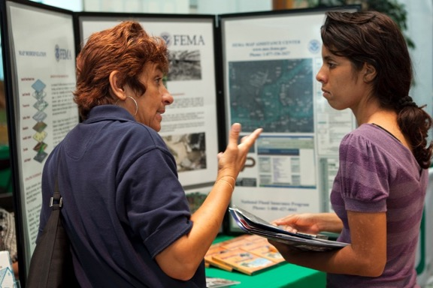

Meeting Image

Flood Sign Image
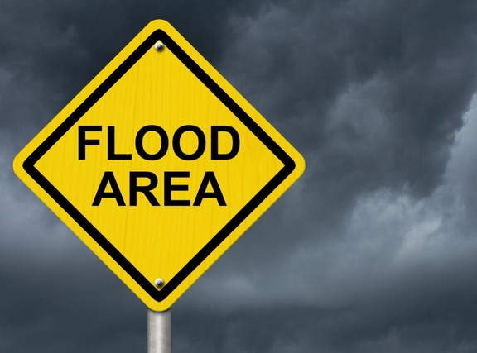

Disaster Assistance Image
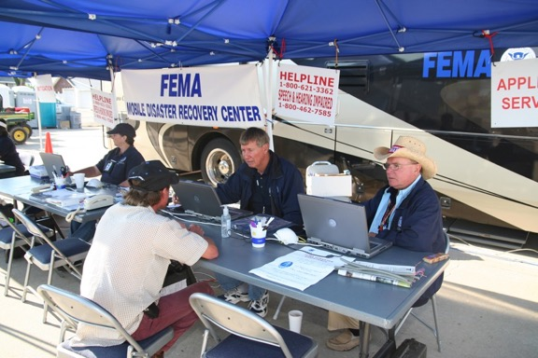

Flooded Street Image
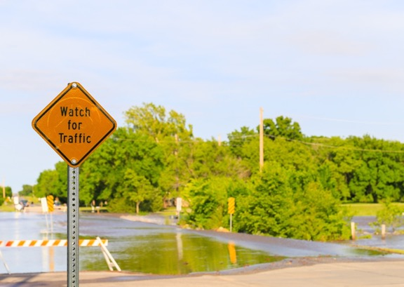

Insurance Adjuster Image
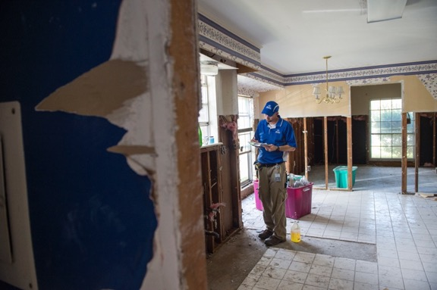

At This Meeting Poster
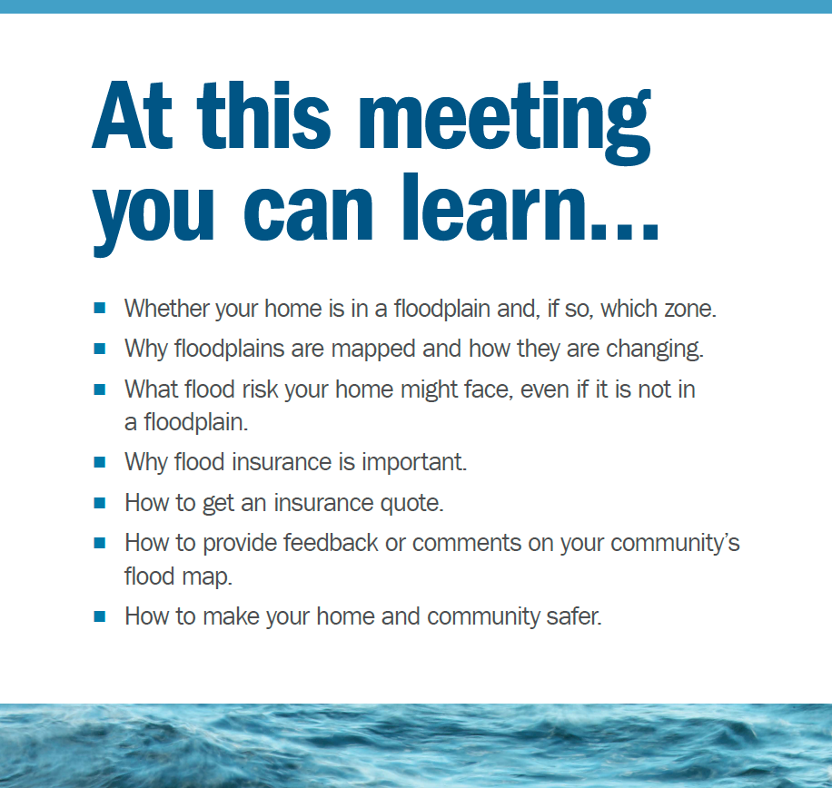

Flood Damage Poster
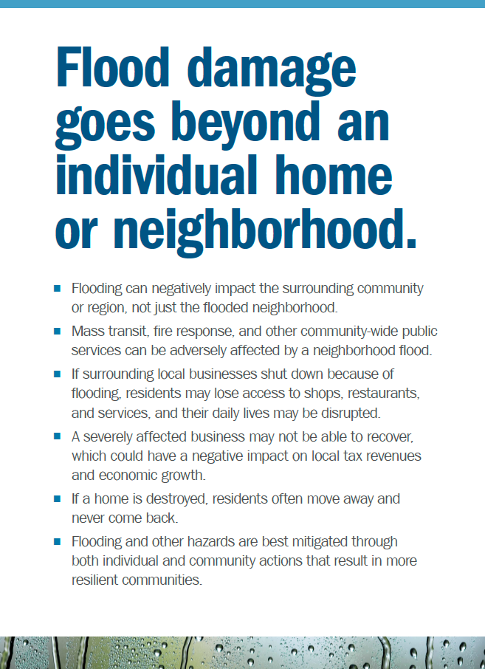

But It Never Floods Poster

