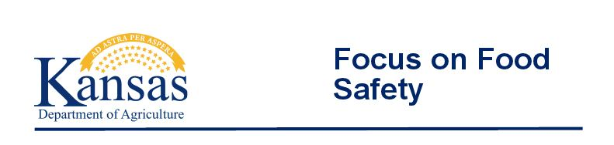
June 19th, 2017
Jefferson County Health Department
1212 Walnut Street
Oskaloosa, KS 66066
1:00 p.m. – 3:00 p.m.

Everyone plays a role in food safety. Preparing high-quality, safe food begins with
well-trained and knowledgeable food service workers.

Focus on Food Safety seminars are designed to help food service workers focus on those items that are critical to safely preparing, cooking, holding, and storing food. The voluntary course is designed to help identify basic steps to help prevent foodborne illness.

This is a free service presented by the Kansas Department of Agriculture’s Food Safety and Lodging Program.

If you are a food service worker at a restaurant, deli or fast food establishment, a community meal provider, a member of a church group that serves food, a daycare provider, a participant in fundraisers that serve food or an individual who wants to improve his or her safe food handling techniques, you should plan to attend this hands-on Focus on Food Safety seminar.

Topics include food safety, protecting food in preparation, protecting food in serving and cleaning and sanitizing.

The course will include demonstrations.

Reservations are required. Contact the Kansas Department of Agriculture’s Division of Food Safety & Lodging at (785) 564-6767.

Kansas Department of Agriculture | 1320 Research Park Drive | Manhattan, KS 66502 | (785) 564-6767 |agriculture.ks.gov

