Submit To:  CHIEF ENGINEER  Division of Water Resources  Kansas Department of Agriculture  1320 Research Park Drive  Manhattan, Kansas 66502  http://agriculture.ks.gov/dwr | APPLICATION FOR TERM PERMIT TO ESTABLISH A MULTI-YEAR FLEX ACCOUNT  (GROUNDWATER ONLY) | 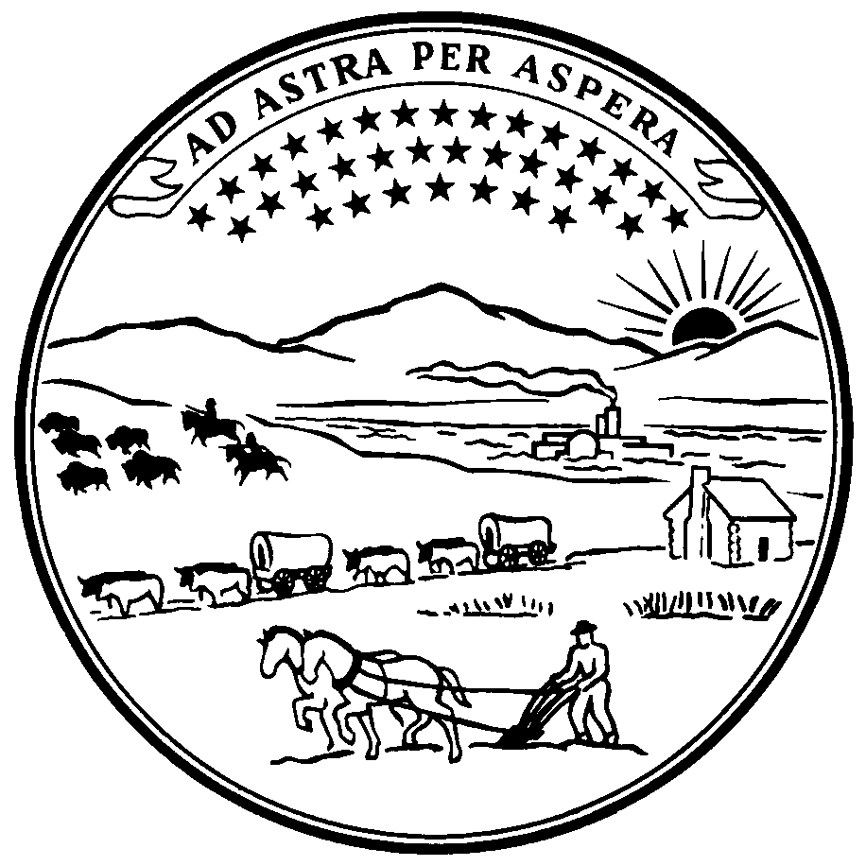  State of Kansas
STATUTORY FILING FEE OF $400.00 MUST ACCOMPANY THIS APPLICATION
(Make check payable to the Kansas Department of Agriculture)
Multi-Year Flex Accounts (also known as “MYFAs”) allow for water management and improved conservation via a term permit for five years of flexible water planning. At the conclusion of the five years, a return to the authorizations under the base water right(s) is automatic. The MYFA program usually can be continued for an additional five-year term, however, by applying for another MYFA term permit when the previous term permit has expired.
Please note that basic requirements under state laws still exist. A list of legal requirements and recommended management practices is part of this application, as “Attachment A”. The terms of this application and the requirements of its Attachment A will be incorporated as conditions of any approved MYFA application and term permit, unless otherwise stated in the approval order.
MYFA Term Permit, File No.
(to be completed by DWR staff)
1. Application is hereby made for approval of the Chief Engineer to establish a Multi-Year Flex Account beginning with calendar year for a point of diversion authorized under File No(s). .
Notes: During the period of the MYFA, the base water right(s) is suspended and may be exercised only under the specific conditions described in K.A.R. 5-16-7.
Base water right(s) must be certified.
Multiple base water rights that have an exact overlap in both point of diversion and place of use must all be included on a single MYFA term permit.
2. Name and address of applicant:
Phone:
Email Address: Agent Owner Tenant
3. Name and address of water use correspondent:
Phone:
Email Address:
4. The proposed place of use under this MYFA is: Same as base water right(s) Supplemental sheet attached
Owner of Land ---- NAME:
ADDRESS:
5. The point of diversion subject to this application, is as follows:
One well or the geographic center of a battery of wells, located in the Quarter
of the Quarter of the Quarter of Section , more particularly described as
being near a point feet North and West of the Southeast Quarter of said section, in
Township South, Range East West (check one) in County, Kansas.
6. All beneficial uses of water authorized under the base water right(s) shall be authorized by a MYFA term permit. If the base water right(s) pertaining to this MYFA authorizes more than one type of use, specify the type of use to be authorized under this specific MYFA term permit (i.e., irrigation, stockwatering, etc.).

7. Specify the rate of diversion for the point of diversion to be authorized by this application. The rate of diversion cannot exceed the authorized rate of diversion for the point of diversion described under Paragraph No. 5 above.
gpm cfs.

8. The proposed quantity of water deposited in the Multi-Year Flex Account shall not exceed the greatest of the following computations.
Water Use Data (NOT to exceed authorized quantity)  AF MGY (check one) |  |  | Reported acres lawfully irrigated:
2000 |  |  | 2000
2001 |  |  | 2001
2002 |  |  | 2002
2003 |  |  | 2003
2004 |  |  | 2004
2005 |  |  | 2005
2006 |  |  | 2006
2007 |  |  | 2007
2008 |  |  | 2008
2009 |  |  | 2009
For Certified Water Rights Approved After December 31, 2004:
Date of Approval: |  | Maximum acres lawfully irrigated during the Perfection Period:

8a. Average Use Calculation  Average Water Use  Average Water Use X 5 years = | 8b. NIR Calculation  Highest number of acres irrigated X  50% NIR (per K.A.R. 5-5-12) in County, KS:  X 5 years X 110% =
8c. Big Bend GMD#5 End Gun Removal Alternative Calculation (only applicable to base water right(s) within GMD#5)
Authorized Quantity X 90% X 5 years =
An approved, signed affidavit verifying that the end gun was removed must be submitted with this MYFA application to qualify for this calculation.
In order to qualify for this calculation, the end gun must be removed for the entire duration of the proposed MYFA period.
Furthermore, in no case may the proposed MYFA quantity exceed the annual authorized quantity of the base water right(s) multiplied by 5.
8d. Base Water Right Annual Authorized Quantity =
Five Times Authorized Quantity =

Add any applicable MYFA carryover quantity of . MYFA carryover is only available when a new MYFA application is being filed during the calendar year in which an existing MYFA expires. The proposed carryover quantity may not exceed the base average usage as computed in 8a AND the proposed MYFA quantity may not exceed the annual authorized quantity of the base water right multiplied by 5 as computed in 8d.
Subtract any applicable penalty, overage, or reduction in quantity of . (Include Attachment B)
9. The authorized quantity under this proposed Multi-Year Flex Account is not to exceed the following quantity to be diverted during the following five (5) consecutive calendar years.
AF MGY | January 1, 20 through December 31, 20
The final authorized quantity will be determined by Division of Water Resources staff based on a review of base water right(s) documentation and may differ from these computations if an error was made (if the quantity is proposed to be reduced, you will be informed and provided an opportunity to withdraw this application).
A MYFA application must be filed with the Chief Engineer on or before December 31st of the first calendar year of the MYFA term for which the application is being made.

10. By signing below as the owner or a duly authorized agent of the owner of the base water right(s), I understand that if this application is approved, a term permit will be issued for a period of not more nor less than five (5) consecutive calendar years and that this term permit will suspend the appropriation of water under the Certificate(s) of Appropriation for Beneficial Use of Water or the Vested Right(s) that is used as the base water right(s) for this MYFA, for the effective period of this MYFA. Such term permit will be subject to state law and applicable rules and regulations, including any applicable groundwater management district regulations. (See Attachment A.)
11. As owner/authorized agent regarding this application, I agree to supply, upon request, any additional documentation necessary to support DWR’s review of this application. I understand that failure to provide all necessary documentation in support of this proposed MYFA will result in the dismissal of this application. Further, I understand that such dismissal will result in the loss of the application filing fee, but shall not limit the applicant’s standing to file subsequent MYFA term-permit applications on this base water right(s) or other base water right(s).
12. I declare that I am the owner of the base water right(s) identified herein, or that I am the representative of the same and I am authorized to make this application in such owner’s behalf, and I declare further that the information provided herein is true, correct, and complete to the best of my knowledge.
13. By signing below, I acknowledge that during the period authorized pursuant to the Multi-Year Flex Account, all conditions thereof are binding upon all owners, heirs, successors, assignees, or lessees of the base water right(s).
NOTE: To be accepted for filing, this application must be signed by at least one owner of the base water right(s) or an authorized representative of same. Before the MYFA can be established and the term permit approved, however, all of the owners of the base water right(s), or their respective authorized representatives, must verify under oath or affirmation that the statements herein are true and complete. If an individual owner is married, the spouse must also sign. Please indicate if there is no spouse. If a water right is being purchased under contract, either by itself or as part of a land transaction, then the seller must sign as owner of the water right until such time as the contract is completed.
In the event that all applicants cannot appear before one notary public, they may, as necessary, sign separate copies of this application before any notary public conveniently available to them. All copies signed in this manner shall be considered to be valid parts of this application.
If this application is signed on behalf of any owner by someone with legal authority to do so (e.g., an agent, one who has power of attorney, or an executor, executrix, conservator), it will be necessary to attach proper documents showing such authority.
Dated at , Kansas, this day of , 20 .
(Owner) Signature |  | (Spouse) Signature
(Owner) Print |  | (Spouse) Print
(Owner) Signature |  | (Spouse) Signature
(Owner) Print |  | (Spouse) Print

State of Kansas )
) SS
County of )
I hereby certify that the foregoing application was signed in my presence and sworn to before me this day of __________, 20___ by _____________________________.

Notary Public

Attachment A
The Multi-Year Flex Account term permit is based upon an existing water right(s). The base water right(s) is, in effect, suspended during the term of the MYFA term permit and may be exercised only under the specific conditions described in K.A.R. 5-16-7. Once the MYFA term ends, however, the base water right(s) resumes, unless the right(s) has been placed in another MYFA or other special program. Unless otherwise stated in the MYFA approval order and term permit or as provided by law, the legal requirements for the base water right(s) apply to the MYFA.
The following are requirements and recommendations regarding any MYFA. The requirements will be incorporated as conditions into any approved MYFA application and term permit, unless otherwise stated in the approval order.
Requirements:
- The applicant/owner/operator will ensure that, prior to the actual first use of water under the MYFA term permit, there is a properly installed water flowmeter on each approved point of diversion under the base water right(s), which flowmeter and its installation meet all of the current specifications described in K.A.R. 5-1-4 through 5-1-12.
- Each such installed water flowmeter and the measuring chamber shall be sealed to the diversion works at the point of diversion in a manner to ensure that the flowmeter and the measuring chamber cannot be removed and reinstalled without breaking the seal, and each water flowmeter register shall be sealed in a manner to ensure that the register cannot be manipulated without breaking the seal.
- The applicant/owner/operator agrees to allow the inspection of the water flowmeter installed to measure water use.
- The applicant/owner/operator agrees to report any and all instances which result in a water flowmeter malfunction on the next business day following the discovery of said malfunction.
- The applicant/owner/operator agrees to repair or replace any malfunctioning water flowmeter within seven (7) days of the discovery of the malfunction or within any authorized extension of time needed to complete the repairs. Any repaired or replaced water flowmeter shall be equipped with anti-reverse gears, and the repair or replacement of the malfunctioning flowmeter will result in the flowmeter and its installation meeting current specifications.
- The applicant/owner/operator agrees to notify the Division of Water Resources in writing on a Water Flowmeter Repair/Replacement Report form prescribed by the Chief Engineer, of the water flowmeter installation and any water flowmeter repair or replacement event.
- The applicant/owner/operator agrees to maintain a record of the quantity diverted under the MYFA term permit at the first of each month of the period of authorization. Further, the applicant/owner/operator agrees to make such information available upon request by the Chief Engineer or his/her authorized representative. If verifiable records to establish water use are not available for a particular year during the MYFA period, then DWR may make certain assumptions on water use for that year, including assigning 150% of the maximum annual quantity of the base water right(s) to that year, or DWR may assess civil penalties and/or revoke the MYFA term permit and suspend the base water right(s) for the duration of the term permit period, pursuant to K.S.A. 82a-736 and other applicable law. (See strongly recommended practices below, regarding backup measurements.)
- The use made of water authorized pursuant to the approved MYFA shall not be changed during the period of the MYFA.
- Any change in the point of diversion or place of use will be based on a change to the base water right(s).
- The MYFA, just like the base water right(s), remains subject to any and all Orders of the Chief Engineer, which includes, but is not limited to: Minimum Desirable Streamflow, Intensive Groundwater Use Control Areas, Local Enhanced Management Areas and/or orders related to impairment of a senior water right.
- Failure to comply with the above referenced stipulations and conditions may result in revocation of the MYFA term permit and the suspension of the base water right(s) for the duration of the term permit period, and/or the assessment of civil penalties as provided in K.S.A. 82a-736, K.A.R. 5-14-10, and other applicable law.
Strongly recommended practices:
Backup measurements: The applicant/owner/operator is strongly encouraged to install and keep verifiable records from a backup water flowmeter or alternate measurement device, such as an hour-meter or other newer technology. In the event that the water flowmeter is broken or found to be inaccurate, the backup measurements may allow DWR to determine the actual amount of water used when accurate water flowmeter records are not available. If there are questions about appropriate backup sources, please contact your local GMD, DWR Field Office, or any private meter resource.

By initialing, the applicant/owner/operator acknowledges receipt of this Attachment A __________

