Owner, operator, or agent in charge signature: ____________________________________

Date: ____________________________________

Example Animal Food Safety Plan
for Multiple Species
Medicated and Non-Medicated Feed

Some City Feed Mill
Animal Food Safety Plan

Background Information

A. Company Overview

This section is not required, however, it is suggested that you summarize your company here. Specifically, this is an area to include any information that may be helpful for an investigator to understand the compliance requirements of your company, such as being an importer of record for raw materials or ingredients, being part of a farm, if you have fewer than 500 employees, or if the value of animal food produced is < $2.5 million or $500,000 with the majority of sales to qualified end-users.

Example:
Company X is an agriculture company with active sales in livestock feed, agronomic chemicals, and fertilizer. As part of our feed business, we manage 4 feed mills and 25 retail stores across the United States. We are considered a Large Business by 21 CFR 507 and provide feed to both qualified end users and intermediaries. We are not a designated importer of animal food, and therefore is not required to comply with the Foreign Supplier Verification Program requirements. As a company, we produce more than $2.5 million in the value of animal food annually and have approximately 600 employees across all our entities. We are committed to our role in helping our customers feed the world in a sustainable, productive manner.

C. Facility Overview

This section is not required, however, it is suggested that you summarize your facility here. Specifically, this is an area to include any information that may be helpful for an investigator to understand the scope of your facility and how it may relate to risk, such as the annual tonnage of animal food produced, if you ship interstate, your largest suppliers and customers, and how customer complaints are gathered and summarized. This is also a good place to identify who is the ‘owner, operator, or agent-in-charge’ and who is ‘management’ of the facility. Finally, it is suggested that you identify the facility’s Preventive Controls Qualified Individual and how qualified individuals are trained.

Example:
- Physical Address
  - 123 First Avenue, Some City, KS, 00000

- Personnel
  - PCQI: Jane Doe (certificate in Apx. A)
  - Mill Manager: John Smith

- Volume/Tonnage
  - Approximately 12,000 tons finished feed weekly for swine, poultry, horse, beef cattle, sheep, and goats sold in bulk or 50-lb bags. Feed may be medicated or non-medicated. We obtain a current medicated feed license and do not use ruminant-derived ingredients except dried milk products.

- Locations of Shipment
  - Local farms in the region, retail stores owned by our company and intermediaries within and out-of-state

- Approximate Hours of Operation: Monday through Friday, 8 AM to 5 PM

- Qualified Individual Training:
  - Qualifications for Job Responsibilities:
    - On-the-job training is completed initially by shadowing. An individual must demonstrate their ability to complete each task before they are allowed to do so unsupervised.
  - Qualifications for Animal Food Safety and Animal Food Hygiene:
    - Completed by watching the training video developed by Kansas State University called “Animal Food Hygiene and Animal Food Safety” located at https://www.youtube.com/watch?v=O6kflfOqxYs.
    - Documentation training and assessment is located in Apx. B.

D. Process Flow

This section is not required, however, it is suggested that you place a block flow diagram here to assist an investigator understand the layout of your facility. This should be unique to each facility and not generically applied across all facilities. For example, if your facility has pelleting capacity but no post-pellet liquid application (PPLA) system, there should be a pelleting process step but not a PPLA step listed. The names of these process steps should match those in your hazard analysis to be as clear as possible. For example, if you list ‘weigh-up’ in the flow diagram, do not list the term as ‘scaling’ in the hazard analysis for the same process step.

Example:
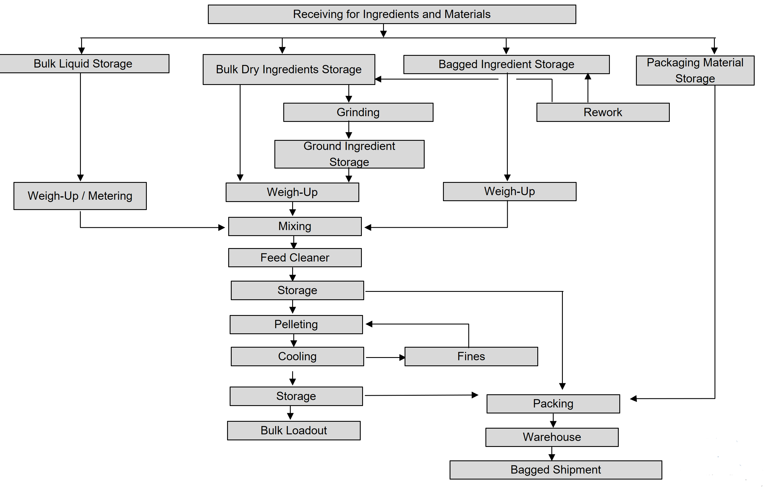

E. Ingredients and Raw Materials

This section is not required, however, it is suggested that you include a summary of ingredients that are used in your facility to assist an investigator understand the scope of your facility and how it may relate to risk, such as the types of medications used. This should be unique to each facility and not generically applied across all facilities. The names of these process steps should match those in your hazard analysis to be as clear as possible. For example, if you list ‘milo’ in this summary, do not list the term as ‘grain sorghum in the hazard analysis.

Example:

DRY BULK INGREDIENTS | LIQUID BULK INGREDIENTS | DRY PACKAGED INGREDIENTS
GRAINS  (E.G. CORN, MILO, WHEAT)  OILSEED MEALS and PLANT BY-PRODUCTS  (E.G. SOYBEAN MEAL, CORN GLUTEN MEAL AND FEED, CORN AND MILO DISTILLERS, WHEAT MIDDS)  MINERAL SOURCES (E.G. MONOCALCIUM AND DICALCIUM PHOSPHATE, LIMESTONE, SALT)  REWORK MATERIAL | CORN OIL | MINERAL PREMIXES  VITAMINS PREMIXES  AMINO ACIDS  MILK PRODUCTS – (E.G. WHEY)  LOW INCLUSION NON-NUTRITIVE INGREDIENTS  (E.G. ENZYMES, MOLD INHIBITORS)  MEDICATED FEED ADDITIVES  (Bacitracin methylene disalicylate, decoquinate, monensin, oxytetracycline, tylosin, virginiamycin)

Current Good Manufacturing Practice

This section is not required, however, it is suggested that you include a summary of these CGMP requirements so you can demonstrate your knowledge of them. It is also suggested to include how you actively work to meet these requirements.

Example:
FSMA CGMP Compliance Requirements - General
Purpose
The purpose of these Current Good Manufacturing Practice (CGMP) requirements include:
- Meeting baseline requirements of the Current Good Manufacturing Practice outlined in Subpart B of 21 CFR 507, the Preventive Controls for Animal Food Rule.
- Communicating the expectations of procedures to employees, customers, and regulatory personnel regarding:
  - Personnel
  - Plant and grounds
  - Sanitation
  - Water supply and plumbing
  - Equipment and utensils
  - Plant operations
  - Holding and distribution (of human food by-product and other product)

Compliance
We complete a CGMP self-audit every quarter to monitor compliance with these requirements. Our most recent audit can be found in Apx. C.

A. Personnel

1. Purpose
Establish baseline training requirements to ensure the production of safe animal food.

2. Scope
All individuals that manufacture, process, pack, or hold animal food.

3. Responsibilities
Management will: 1) verify that all relevant personnel complete required training prior to independently performing their assigned duties, 2) direct employees to report illness to supervisor, 3) ensure proper procedures are followed.

4. Procedure
- Individuals will:
  - Control personal items.
    - Items allowed in the manufacturing area that may be a potential source of contamination if dropped in animal food should be secured or stored properly, including jewelry, cell phones, pens, personal protective equipment, and tools.
  - Ensure employee health does not contaminate animal food by:
    - Reporting vomiting, diarrhea, or fever to management.
    - Washing hands, if necessary, prior to contact with animal food or contact surfaces.
  - Maintain adequate personal hygiene and cleanliness by:
    - Keeping hands and arms clean so they do not introduce a source of contamination to animal food, animal food contact surfaces, or animal food packaging material.
      - Hands should be properly washed or sanitized:
        - After using the toilet
        - If contaminated with toxic material
      - Proper hand washing procedure includes:
        - Applying soap and warm water
        - Rubbing hands together vigorously (approximately 20 s)
        - Rinsing hands with warm, clean water
        - Drying hands with clean towel or air dryer
  - Take other necessary precautions to protect against contamination of animal food, including:
    - Report the presence of any unauthorized personnel to management.
    - Restricting belongings, such as clothing and food or drink, to designated areas where they do not constitute a source of contamination.
5. References
FDA Employee Health and Personal Hygiene Handbook
21 CFR 507.14

B. Plant and Grounds

1. Purpose
Establish baseline training requirements to ensure the production of safe animal food.

2. Scope
All individuals that manufacture, process, pack, or hold animal food.

3. Responsibilities
Management will: 1) verify that all relevant personnel complete required training prior to independently performing their assigned duties, 2) ensure proper procedures are followed.

4. Procedure
- Grounds will be maintained to minimize sources of pest harborage or other potential contamination, including:
  - Storing equipment, litter, and waste in designated areas, including proper waste treatment and disposal.
  - Maintaining vegetation, driveways, and parking areas, including ensuring adequate drainage of grounds.
- The animal food manufacturing area will be suitable for purpose, including:
  - Providing adequate space for cleaning and maintenance of equipment.
  - Controlling drip and condensate that may be a source of contamination.
  - Adequately ventilating vapors, steam, and fumes that may be a source of contamination.
  - Providing adequate and shatter-resistant lighting throughout handwashing, toilet, and areas where animal food is manufactured, processed, packed, or held.

5. Reference
21 CFR 507.17

C. Sanitation

1. Purpose
Establish baseline training requirements to ensure the production of safe animal food.

2. Scope
All individuals that manufacture, process, pack, or hold animal food.

3. Responsibilities
Management will: 1) verify that all relevant personnel complete required training prior to independently performing their assigned duties, 2 ensure proper procedures are followed.

4. Procedure
- The areas where animal food is manufactured and animal food packaging material stored must be kept clean and in good repair.
- Surfaces of utensils and equipment must be cleaned, maintained, and stored as appropriate to protect against the contamination of animal food, animal food contact surfaces, and animal food packaging material.
  - Surfaces in this facility are not wet-cleaned, and wet-processing is not used.
- Cleaning compounds and sanitizing agents must be safe and adequate for their intended use.
- Toxic materials will be allowed into areas where animal food is manufactured, processed, or exposed only if they are necessary for sanitation, laboratory testing, maintenance, or plant operations.
  - These materials must be identified, stored, and used appropriately so they are not a potential source of contamination.
- Effective pest control must be implemented, and pesticides controlled so as to not be a potential source of contamination.
- Trash must be conveyed, stored, and disposed of properly to protect against the contamination of animal food, animal food contact surfaces, or animal food packaging material, and from being a potential source of pest harborage.

5. Reference
21 CFR 507.19

D. Water Supply and Plumbing

1. Purpose
Establish baseline training requirements to ensure the production of safe animal food.

2. Scope
All individuals that manufacture, process, pack, or hold animal food.

3. Responsibilities
Management will: 1) verify that all relevant personnel complete required training prior to independently performing their assigned duties, 2) ensure proper procedures are followed.

4. Procedure
- All water:
  - Is safe for use, based on records from municipal water supplier or well certification.
- Plumbing must avoid being a source of contamination and be capable of:
  - Carrying sufficient quantities of water to its designated location.
  - Conveying sewage and liquid waste, which must be disposed of adequately.
  - Providing adequate drainage within the plant.
  - Ensuring no backflow or cross-connection between systems for discharge waste water or sewage and those for water to be used in animal food manufacturing.
- Clean and accessible toilet and hand washing facilities must be provided for employees.

5. Reference
21 CFR 507.20

E. Equipment and Utensils

1. Purpose
Establish baseline training requirements to ensure the production of safe animal food.

2. Scope
All individuals that manufacture, process, pack, or hold animal food.

3. Responsibilities
Management will: 1) verify that all relevant personnel complete required training prior to independently performing their assigned duties, 2) ensure proper procedures are followed.

4. Procedure
- All equipment and utensils will be designed and constructed to be adequately cleanable and must be properly maintained.
  - Must be used properly so as to not be a source of adulteration.
  - Equipment must be installed to allow for its cleaning and maintenance, as well as the cleaning and maintenance of adjacent space.
  - Animal food contact surfaces must be nontoxic, maintained, and capable of withstanding their use, cleaning, and sanitation.
- All systems, such as conveying and holding systems, must be designed, constructed, and maintained to protect against contamination of animal food.
- Compressed air will only be used to clean when its use will not result in potential contamination of animal food.

5. Reference
21 CFR 507.22

F. Plant Operations

1. Purpose
Establish baseline training requirements to ensure the production of safe animal food.

2. Scope
All individuals that manufacture, process, pack, or hold animal food.

3. Responsibilities
Management will: 1) verify that all relevant personnel complete required training prior to independently performing their assigned duties, 2) ensure proper procedures are followed.

4. Procedure
- Raw material and rework must be identified separately from finished product.
- Animal food packaging materials must be safe and suitable for their intended use.
- The overall cleanliness of the animal food area is under the supervision of the animal food manager or designee.
- Precautions are taken so plant operations do not contribute to contamination.
- Adulterated animal food must be reprocessed or disposed of, as appropriate.
- Raw materials must be examined to ensure their suitability.
- Rework must be handled to protect against contamination.

5. Reference
21 CFR 507.25

G. Holding and Distribution

1. Purpose
Establish baseline training requirements to ensure the production of safe animal food.

2. Scope
All individuals that manufacture, process, pack, or hold animal food.

3. Responsibilities
Management will: 1) verify that all relevant personnel complete required training prior to independently performing their assigned duties, 2) ensure proper procedures are followed.

4. Procedure
- Finished product will be held in a matter to prevent against contamination and minimize deterioration. Specifically:
  - Containers used to hold product before distribution must be designed, constructed, cleaned, and maintained to protect against contamination, such as trash.
  - The labeling for the animal food ready for distribution must contain, when applicable, information and instructions for safely using the animal food for the intended animal species.
  - Bulk vehicles used to distribute animal food must be examined prior to use to protect against the contamination of animal food from the vehicle when the facility is responsible for transporting the animal food itself or arranges with a third party to transport the animal food.
  - Animal food returned from distribution must be assessed for animal food safety to determine the appropriate disposition. Returned animal food must be identified as such and segregated until assessed.
  - Bulk animal food must be held in a manner that does not result in unsafe cross contamination with other animal food.

5. Reference
21 CFR 507.27 and 507.28

Hazard Analysis
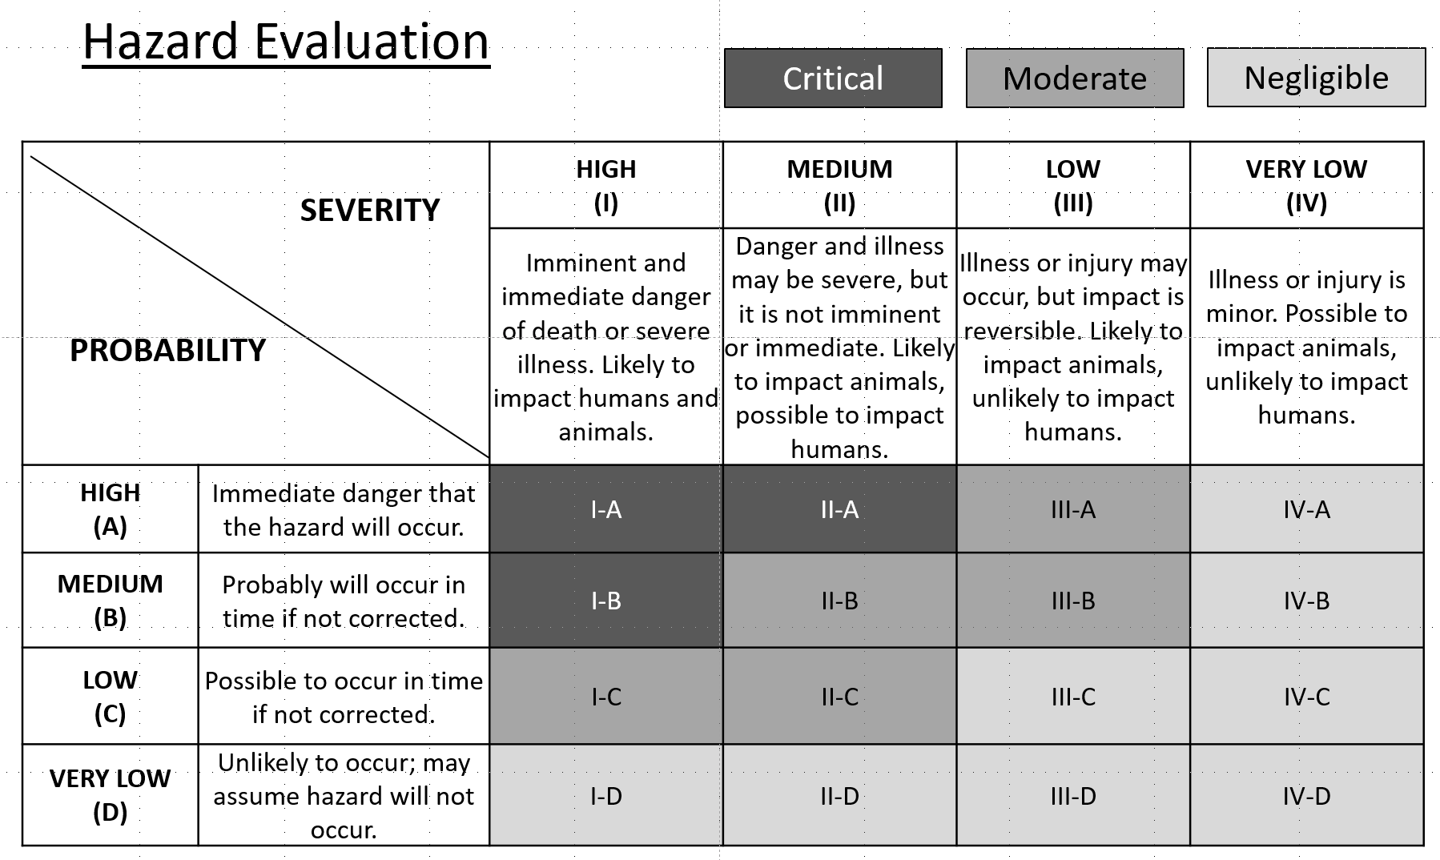

Plant Name: Some City Feed Mill
Address: 123 First Avenue, Some City, KS, 00000
Animal Food: Dry medicated and non-medicated complete feed
Intended Species: Swine, poultry, equine, beef cattle, sheep, and goats
Life Stage/Production Class: All life stages
Ingredient or Processing Step | Known or Reasonably Foreseeable Hazard | Severity of Illness or Injury to Humans or Animals if the Hazard Were to Occur | Probability that the Hazard Will Occur in Absence of Preventive Controls | Does the Known or Reasonably Foreseeable Hazard Require a PC? | Explanation/  Justification | Preventive Control Applied | Is the Preventive Control Applied at this Step?
Corn and corn co-products (DDGS, corn gluten feed, corn gluten meal) | P - Foreign Material | IV – Very Low | B - Moderate | No | Moderate probability, which is reduced by grates over receiving pit and pit cover in place except when receiving is being conducted. Very low severity to impact animal health and no impact on human health. | n/a | n/a
 | C – Aflatoxin and fumonisin | III – Low | B -Moderate | No | Low severity because they could impact animal health but little pass-through risk through meat tissue to impact human health. The mycotoxin management prerequisite program reduces probability to a moderate level. See in Apx. D1. | n/a | n/a
 | C - Animal Drug Residue (for DDGS) | IV – Very Low | C –Low | No | Very low severity because residual levels are below those expected to cause animal or human illness or injury. Low probability because the 2010 FDA surveillance (Apx. D5) reported 8.7% of DDGS had quantifiable antibiotic residues. | n/a | n/a
 | C - Pesticides | III – Low | C - Low | No | Low severity because they could impact animal health but pose little pass-through risk through fat or meat tissue to impact human health. Low probability because 2018 FDA surveillance (Apx. D2) shows 2.3% of analyzed whole grains/seeds were above threshold pesticide levels. Incoming grains are secured locally. | n/a | n/a
 | B - Salmonella spp. | III – Low | D – Very Low | No | Low severity because only a few select serotypes are considered an adulterant in the species for which we make feed (CPG 690.800) and there is no knowledge of impact in human health. Very low probability of this serotype in animal feed or ingredients (Li et al., 2012) References in Apx. D3 and D4. | n/a | n/a

Ingredient or Processing Step | Known or Reasonably Foreseeable Hazard | Severity of Illness or Injury to Humans or Animals if the Hazard Were to Occur | Probability that the Hazard Will Occur in Absence of Preventive Controls | Does the Hazard Require a PC? | Explanation/  Justification | Preventive Control Applied | Is the Preventive Control Applied at this Step?
Milo and milo DDGS | P - Foreign Material | IV – Very Low | B - Moderate | No | Moderate probability, which is reduced by grates over receiving pit and pit cover in place except when receiving is being conducted. Very low severity to impact animal health and no impact on human health. | n/a | n/a
 | C – Aflatoxin, fumonisin, and Deoxynilvalenol aka Vomitoxin | III –Low | D –Very Low | No | Low severity because they could impact animal health but little pass-through risk through meat tissue to impact human health. Very low probability because milo is inherently resistant to mycotoxins, so it is not part of the mycotoxin management prerequisite program. | n/a | n/a
 | C - Animal Drug Residue (for DDGS) | IV – Very Low | C –Low | No | Very low severity because residual levels are below those expected to cause animal or human illness or injury. Low probability because the 2010 FDA surveillance (Apx. D5) reported 8.7% of DDGS had quantifiable antibiotic residues. | n/a | n/a
 | C - Pesticides | III – Low | C - Low | No | Low severity because they could impact animal health but pose little pass-through risk through fat or meat tissue to impact human health. Low probability because 2018 FDA surveillance (Apx. D2) shows 2.3% of analyzed whole grains/seeds were above threshold pesticide levels. Incoming grains are secured locally. | n/a | n/a
 | B - Salmonella spp. | III – Low | D – Very Low | No | Low severity because only a few select serotypes are considered an adulterant in the species for which we make feed (CPG 690.800) and there is no knowledge of impact in human health. Very low probability of this serotype in animal feed or ingredients (Li et al., 2012) References in Apx. D3 and D4. | n/a | n/a
Ingredient or Processing Step | Known or Reasonably Foreseeable Hazard | Severity of Illness or Injury to Humans or Animals if the Hazard Were to Occur | Probability that the Hazard Will Occur in Absence of Preventive Controls | Does the Hazard Require a PC? | Explanation/  Justification | Preventive Control Applied | Is the Preventive Control Applied at this Step?
Wheat and wheat midds | P - Foreign Material | IV – Very Low | B - Moderate | No | Moderate probability, which is reduced by grates over receiving pit and pit cover in place except when receiving is being conducted. Very low severity to impact animal health and no impact on human health. | n/a | n/a
 | C – Deoxynilvalenol aka Vomitoxin | IV – Very Low | B -Moderate | No | Very low severity because they could impact animal health but no documented pass-through risk through meat tissue to impact human health. The mycotoxin management prerequisite program reduces probability to a moderate level. See in Apx. D1. | n/a | n/a
 | C - Pesticides | III – Low | C - Low | No | Low severity because they could impact animal health but pose little pass-through risk through fat or meat tissue to impact human health. Low probability because 2018 FDA surveillance (Apx. D2) shows 2.3% of analyzed whole grains/seeds were above threshold pesticide levels. Incoming grains are secured locally. | n/a | n/a
 | B - Salmonella spp. | III – Low | D – Very Low | No | Low severity because only a few select serotypes are considered an adulterant in the species for which we make feed (CPG 690.800) and there is no knowledge of impact in human health. Very low probability of this serotype in animal feed or ingredients (Li et al., 2012) References in Apx. D3 and D4. | n/a | n/a

Ingredient or Processing Step | Known or Reasonably Foreseeable Hazard | Severity of Illness or Injury to Humans or Animals if the Hazard Were to Occur | Probability that the Hazard Will Occur in Absence of Preventive Controls | Does the Hazard Require a PC? | Explanation/  Justification | Preventive Control Applied | Is the Preventive Control Applied at this Step?
Soybean meal | P - None | n/a | n/a | n/a | n/a | n/a | n/a
 | C - Economic Adulterants | III - Low | D – Very Low | No | Severity is low because an economic adulterant would like impact animal health but has little pass-through risk through meat tissue to impact human health. Very low probability because there is no history of occurrence. Receiving process is observed for unusual residues to reduce probability. | n/a | n/a
 | C - Pesticides | III – Low | C - Low | No | Low severity because they could impact animal health but pose little pass-through risk through fat or meat tissue to impact human health. Low probability because 2018 FDA surveillance (Apx. D2) shows 4.2% of analyzed plant byproducts were above threshold pesticide levels. | n/a | n/a
 | B - Salmonella spp. | III – Low | D – Very Low | No | Low severity because only a few select serotypes are considered an adulterant in the species for which we make feed (CPG 690.800) and there is no knowledge of impact in human health. Very low probability of this serotype in animal feed or ingredients (Li et al., 2012) References in Apx. D3 and D4. | n/a | n/a

Ingredient or Processing Step | Known or Reasonably Foreseeable Hazard | Severity of Illness or Injury to Humans or Animals if the Hazard Were to Occur | Probability that the Hazard Will Occur in Absence of Preventive Controls | Does the Hazard Require a PC? | Explanation/  Justification | Preventive Control Applied | Is the Preventive Control Applied at this Step?
Bulk minerals (monocalcium or dicalcalcium phosphate, limestone, salt)  Bagged minerals and vitamins (vitamin-trace mineral premixes) | P - Foreign Material | IV – Very Low | B - Moderate | No | Very low severity to impact animal health and no impact on human health. Moderate probability, which is reduced by grates and subsequent magnets. | n/a | n/a
 | C - Environmental and Industrial Chemicals | II - Moderate | D – Very Low | No | Moderate severity because it could impact animal health substantially and has risk to carry into tissues consumed by humans as food. Minerals that are likely associated with dioxins are sourced from facilities that follow GMP to reduce dioxin formation during processing. A letter of conformance is available to demonstrate this from the supplier(s). Very low probability with incoming ingredients are secured from approved suppliers. | n/a | n/a
 | C – Nutrient deficiencies and toxicities (esp. copper toxicity in sheep) | III – Low | B- Moderate | No | Low severity because it could be toxic to animal health, especially copper toxicity in sheep, but has no risk to carry into tissues consumed by humans as food. Moderate probability because all premixes are from a similar supplier and can be easily confused, but probability is reduced by employee training focused in this area. | n/a | n/a
 | C - Heavy Metals | II – Moderate | D – Very Low | No | Moderate severity because it could impact animal health substantially and has risk to carry into tissues consumed by humans as food. Very low probability with incoming ingredients are secured from approved suppliers A letter of conformance is available to demonstrate this from the supplier(s). | n/a | n/a
 | B - None | n/a | n/a | n/a | n/a | n/a | n/a

Ingredient or Processing Step | Known or Reasonably Foreseeable Hazard | Severity of Illness or Injury to Humans or Animals if the Hazard Were to Occur | Probability that the Hazard Will Occur in Absence of Preventive Controls | Does the Hazard Require a PC? | Explanation/  Justification | Preventive Control Applied | Is the Preventive Control Applied at this Step?
Rework | P - Foreign Material | IV- Very Low | B - Moderate | No | Very low severity to impact animal health and no impact on human health. Moderate probability, which is reduced by grates and subsequent magnets. | n/a | n/a
 | C - Nutrient Deficiency or Toxicity | III – Low | D – Very Low | No | Low severity because it can impact animal health widely, but has no impact on human health. Very low severity because rework is only conducted under the supervision of a consulting Ph.D. nutritionist who supervises formulation to ensure nutrient deficiency or toxicity does not occur in subsequent use. | n/a | n/a
 | C - Animal Drug Carryover | II – Moderate | C - Low | No | Moderate severity because levels can impact animal health widely, but would not be lethal to human health. Rework and returned feed may contain animal drugs. Low probability because their inclusion resulting in a hazard is reduced by adhering to 21 CFR 225 CGMP requirements, including sequencing. | n/a | n/a
 | B - None | n/a | n/a | n/a | n/a | n/a | n/a

Ingredient or Processing Step | Known or Reasonably Foreseeable Hazard | Severity of Illness or Injury to Humans or Animals if the Hazard Were to Occur | Probability that the Hazard Will Occur in Absence of Preventive Controls | Does the Hazard Require a PC? | Explanation/  Justification | Preventive Control Applied | Is the Preventive Control Applied at this Step?
Corn oil | P - None | n/a | n/a | No | n/a | n/a | n/a
 | C - Environmental and Industrial Chemicals | II - Moderate | D – Very Low | No | Moderate severity because PCBs could impact animal health substantially and has risk to carry into tissues consumed by humans as food. A letter of conformance is available to demonstrate this from the supplier(s). Very low probability with incoming ingredients are secured from approved suppliers. | n/a | n/a
 | C - Pesticides | III – Low | D – Very Low | No | Low severity because they could impact animal health but pose little pass-through risk through fat or meat tissue to impact human health. Very low probability because 2018 FDA surveillance (Apx. D2) shows 0.0% of analyzed oils were above threshold pesticide levels. Incoming grains are secured locally. | n/a | n/a
 | B - None | n/a | n/a | No | n/a | n/a | n/a
Synthetic lysine, threonine, methionine, tryptophan  Phytase, carbohydrase and protease enzymes | P - None | n/a | n/a | No | n/a | n/a | n/a
 | C - None | n/a | n/a | No | n/a | n/a | n/a
 | B - None | n/a | n/a | No | n/a | n/a | n/a

Ingredient or Processing Step | Known or Reasonably Foreseeable Hazard | Severity of Illness or Injury to Humans or Animals if the Hazard Were to Occur | Probability that the Hazard Will Occur in Absence of Preventive Controls | Does the Hazard Require a PC? | Explanation/  Justification | Preventive Control Applied | Is the Preventive Control Applied at this Step?
Medicated feed additives | P - None | n/a | n/a | No | n/a | n/a | n/a
 | C – Animal drug carryover | II – Moderate | D – Very Low | No | Moderate severity because low-level carryover may be toxic in some species, such as monensin sodium in horse feed, but with little to no impact human health. Very low probability because facility is a licensed feed mill that complies with 21 CFR 225 requirements with no history of problems. | n/a | n/a
 | B - None | n/a | n/a | No | n/a | n/a | n/a

Ingredient or Processing Step | Known or Reasonably Foreseeable Hazard | Severity of Illness or Injury to Humans or Animals if the Hazard Were to Occur | Probability that the Hazard Will Occur in Absence of Preventive Controls | Does the Hazard Require a PC? | Explanation/  Justification | Preventive Control Applied | Is the Preventive Control Applied at this Step?
Dried whey | P - None | n/a | n/a | No | n/a | n/a | n/a
 | C - None | n/a | n/a | No | n/a | n/a | n/a
 | B - Salmonella spp. | III – Low | D – Very Low | No | Low severity because only a few select serotypes are considered an adulterant in the species for which we make feed (CPG 690.800) and there is no knowledge of impact in human health. Very low probability of this serotype in animal feed or ingredients (Li et al., 2012) References in Apx. D3 and D4. | n/a | n/a

Ingredient or Processing Step | Known or Reasonably Foreseeable Hazard | Severity of Illness or Injury to Humans or Animals if the Hazard Were to Occur | Probability that the Hazard Will Occur in Absence of Preventive Controls | Does the Hazard Require a PC? | Explanation/  Justification | Preventive Control Applied | Is the Preventive Control Applied at this Step?
Receiving | P - Foreign Material | IV- Very Low | B - Moderate | No | Very low severity to impact animal health and no impact on human health. Moderate probability, which is reduced by grates and subsequent magnets. | n/a | n/a
 | C - Hydraulic fluid or other chemicals from trucks | III - Low | C – Low | No | Low severity because they could impact animal health but pose little pass-through risk through fat or meat tissue to impact human health. Low probability because receiving and the associated vehicles are visually observed during unloading per CGMP. | n/a | n/a
 | B - Salmonella spp. | III – Low | D – Very Low | No | Low severity because only a few select serotypes are considered an adulterant in the species for which we make feed (CPG 690.800) and there is no knowledge of impact in human health. Very low probability of this serotype in animal feed or ingredients (Li et al., 2012) References in Apx. D3 and D4. | n/a | n/a

Ingredient or Processing Step |  | Known or Reasonably Foreseeable Hazard |  | Severity of Illness or Injury to Humans or Animals if the Hazard Were to Occur |  | Probability that the Hazard Will Occur in Absence of Preventive Controls |  | Does the Hazard Require a PC? |  | Explanation/  Justification | Preventive Control Applied | Is the Preventive Control Applied at this Step?
Ingredient (whole and ground) storage |  | P - None |  | n/a |  | n/a |  | n/a |  | n/a | n/a | n/a
 |  | C – Aflatoxin, fumonisin, and deoxynilvalenol or vomitoxin |  | III – Low |  | B -Moderate |  | No |  | Low severity because they could impact animal health but little pass-through risk through meat to impact human health. Moderate probability because ingredients susceptible to mycotoxin are held at low moisture and ambient temperatures to limit growth. When prevalent and not stored within the mill complex, it is covered and re-evaluated as a new ingredient prior to use that falls under mycotoxin management prerequisite program. | n/a | n/a
 |  | B - None |  | n/a |  | n/a |  | n/a |  | n/a | n/a | n/a
Grinding |  | P - Metal |  | IV – Very Low |  | C – Low |  | No |  | Moving metal parts may introduce metal. Very low severity to impact animal health and no impact on human health. Low probability because magnets and screens limit this occurrence. | n/a | n/a
 |  | C - None |  | n/a |  | n/a |  | n/a |  | n/a | n/a | n/a
 |  | B - None |  | n/a |  | n/a |  | n/a |  | n/a | n/a | n/a
Weigh-up |  | P - None |  | n/a |  | n/a |  | No |  | n/a | n/a | n/a
 |  | C - Nutrient Deficiencies and Toxicities |  | III – Low |  | D – Very Low |  | No |  | Low severity because it can impact animal health widely, but has no impact on human health. Very low probability because formulation is under the supervision of a Ph.D. nutritionist to ensure nutrient deficiency or toxicity does not occur. | n/a | n/a
 |  | C - Animal Drug Contamination |  | II – Moderate |  | C - Low |  | No |  | Moderate severity because levels can impact animal health widely, but would not be lethal to human health. Low probability because their inclusion resulting in a hazard is reduced by adhering to 21 CFR 225 CGMP requirements, including sequencing. | n/a | n/a
 |  | B - None |  | n/a |  | n/a |  | No |  | n/a | n/a | n/a
Ingredient or Processing Step | Known or Reasonably Foreseeable Hazard |  | Severity of Illness or Injury to Humans or Animals if the Hazard Were to Occur |  | Probability that the Hazard Will Occur in Absence of Preventive Controls |  | Does the Hazard Require a PC? |  | Explanation/  Justification |  | Preventive Control Applied | Is the Preventive Control Applied at this Step?
Mixing | P - Metal |  | IV – Very Low |  | C – Low |  | No |  | Moving metal parts may introduce metal. Very low severity to impact animal health and no impact on human health. Low probability because a magnet limits this occurrence. |  | n/a | n/a
 | C - Nutrient Deficiencies and Toxicities |  | III – Low |  | D – Very Low |  | No |  | Low severity because it can impact animal health widely, but has no impact on human health. Very low probability because mixer efficiency is evaluated at least annually. |  | n/a | n/a
 | C - Animal Drug Contamination |  | II – Moderate |  | C - Low |  | No |  | Moderate severity because levels can impact animal health widely, but would not be lethal to human health. Low probability because their inclusion resulting in a hazard is reduced by adhering to 21 CFR 225 CGMP requirements, including sequencing. |  | n/a | n/a
 | B - None |  | n/a |  | n/a |  | n/a |  | n/a |  | n/a | n/a
Feed cleaner | P - Metal |  | IV – Very Low |  | C – Low |  | No |  | Moving metal parts may introduce metal. Very low severity to impact animal health and no impact on human health. Low probability because a magnet at this step limits occurrence in finished feed. |  | n/a | n/a
 | C - Animal Drug Contamination |  | II – Moderate |  | C - Low |  | No |  | Moderate severity because levels can impact animal health widely, but would not be lethal to human health. Low probability because their inclusion resulting in a hazard is reduced by adhering to 21 CFR 225 CGMP requirements, including sequencing. |  | n/a | n/a
 | B - None |  | n/a |  | n/a |  | n/a |  | n/a |  | n/a | n/a

Ingredient or Processing Step | Known or Reasonably Foreseeable Hazard | Severity of Illness or Injury to Humans or Animals if the Hazard Were to Occur | Probability that the Hazard Will Occur in Absence of Preventive Controls | Does the Hazard Require a PC? | Explanation/  Justification | Preventive Control Applied | Is the Preventive Control Applied at this Step?
Feed storage | P - None | n/a | n/a | No | n/a | n/a | n/a
 | C - Animal Drug Contamination | II – Moderate | C - Low | No | Moderate severity because levels can impact animal health widely, but would not be lethal to human health. Low probability because their inclusion resulting in a hazard is reduced by adhering to 21 CFR 225 CGMP requirements, including sequencing. | n/a | n/a
 | C - Nutrient Deficiencies and Toxicities | III – Low | D – Very Low | No | Low severity because it can impact animal health widely, but has no impact on human health. Very low probability because flushing and sequencing protocols are used to prevent copper toxicity from carryover in sheep feed. | n/a | n/a
 | B - None | n/a | n/a | n/a | n/a | n/a | n/a
Pelleting | P - Metal | IV – Very Low | C – Low | No | Moving metal parts may introduce metal. Very low severity to impact animal health and no impact on human health. Low probability because a magnet at this step limits occurrence in finished feed. | n/a | n/a
 | C - Animal Drug Contamination | II – Moderate | C - Low | No | Moderate severity because levels can impact animal health widely, but would not be lethal to human health. Low probability because their inclusion resulting in a hazard is reduced by adhering to 21 CFR 225 CGMP requirements, including sequencing. | n/a | n/a
 | C - Nutrient Deficiencies and Toxicities | III – Low | D – Very Low | No | Low severity because it can impact animal health widely, but has no impact on human health. Very low probability because flushing and sequencing protocols are used to prevent copper toxicity from carryover in sheep feed. | n/a | n/a
 | B - None | n/a | n/a | n/a | n/a | n/a | n/a

Ingredient or Processing Step | Known or Reasonably Foreseeable Hazard | Severity of Illness or Injury to Humans or Animals if the Hazard Were to Occur | Probability that the Hazard Will Occur in Absence of Preventive Controls | Does the Hazard Require a PC? | Explanation/  Justification | Preventive Control Applied | Is the Preventive Control Applied at this Step?
Cooling and Fines Addition | P - Metal | IV – Very Low | C – Moderate | No | Moving metal parts may introduce metal. Very low severity to impact animal health and no impact on human health. Moderate probability because preventive maintenance limits its occurrence. | n/a | n/a
 | C - Animal Drug Contamination | II – Moderate | C - Low | No | Moderate severity because levels can impact animal health widely, but would not be lethal to human health. Low probability because their inclusion resulting in a hazard is reduced by adhering to 21 CFR 225 CGMP requirements, including sequencing. | n/a | n/a
 | C - Nutrient Deficiencies and Toxicities | III – Low | D – Very Low | No | Low severity because it can impact animal health widely, but has no impact on human health. Very low probability because flushing and sequencing protocols are used to prevent copper toxicity from carryover in sheep feed. | n/a | n/a
 | B - Salmonella spp. | III – Low | D – Very Low | No | Low severity because only a few select serotypes are considered an adulterant in the species for which we make feed (CPG 690.800) and there is no knowledge of impact in human health. Very low probability of this serotype in animal feed or ingredients (Li et al., 2012) References in Apx. D3 and D4. | n/a | n/a

Ingredient or Processing Step | Known or Reasonably Foreseeable Hazard | Severity of Illness or Injury to Humans or Animals if the Hazard Were to Occur | Probability that the Hazard Will Occur in Absence of Preventive Controls | Does the Hazard Require a PC? | Explanation/  Justification | Preventive Control Applied | Is the Preventive Control Applied at this Step?
Bulk loadout and packing – warehouse – bagged shipment | P - Metal | IV – Very Low | C – Moderate | No | Moving metal parts may introduce metal. Very low severity to impact animal health and no impact on human health. Moderate probability because preventive maintenance limits its occurrence. | n/a | n/a
 | C - Animal Drug Contamination | II – Moderate | C - Low | No | Moderate severity because levels can impact animal health widely, but would not be lethal to human health. Low probability because their inclusion resulting in a hazard is reduced by adhering to 21 CFR 225 CGMP requirements, including sequencing. | n/a | n/a
 | C - Nutrient Deficiencies and Toxicities | III – Low | D – Very Low | No | Low severity because it can impact animal health widely, but has no impact on human health. Very low probability because flushing and sequencing protocols are used to prevent copper toxicity from carryover in sheep feed. | n/a | n/a
 | B - Salmonella spp. | III – Low | D – Very Low | No | Low severity because only a few select serotypes are considered an adulterant in the species for which we make feed (CPG 690.800) and there is no knowledge of impact in human health. Very low probability of this serotype in animal feed or ingredients (Li et al., 2012) References in Apx. D3 and D4. | n/a | n/a

Preventive Controls

Currently, there are no hazards requiring a preventive control, and therefore no preventive controls are deemed necessary.

Recall Plan

This section is not required in this example because there are no hazards requiring a preventive control. However, it is suggested that you include a recall plan so you can demonstrate your knowledge of its requirements and your planned actions if a recall were to be necessary.

Example:

A. Assigned Responsibilities
Mill Manager
- Responsible for the implementation and maintenance of the Recall Procedures
Recall Coordinator
- Has authority from management to make recall decisions on behalf of the company
- Will initiate the formation of a committee and will coordinate actions with FDA and our marketing and distribution agents.

B. Procedures

Decision to Recall - Determined by Recall Coordinator
The decision on whether to recall or withdraw a feed or not will be based on the identification of a hazard that makes a feed unsafe and its likelihood of affecting animal or human health. This will be determined by careful, considered risk assessment. A risk assessment will be conducted, and may include collaboration with regulatory authorities to determine if a recall is necessary.

Scope of Recall - Determined by Recall Coordinator
The scope of a recall is a very important part of the process; it ultimately ensures the effective identification of all affected product.

Notification of a product recall - Determined by Recall Coordinator
If the decision is taken to initiate a recall, we will notify:
• Senior management
• Regulatory authority
• Consignees (distribution chain and consumer)
• The public, via the media contact, if necessary

Communication - Determined by Recall Coordinator
Notification in respect to the recall needs to be done promptly and should cover the following areas:
1. Regulatory Authority: We will notify the appropriate regulator at the earliest opportunity, after an incident is identified that may lead to a recall. The regulatory authority will be updated throughout the process.

2. Distribution Chain: We will notify contacts by telephone and fax or email.

1. Notification of Direct Consignees
The following consignee list will be compiled:

Direct Account Types | Number
Retail stores
Intermediaries
End-users

Consignees will be notified by mail, phone, facsimile or e-mail. NOTE: It is advisable to include a written notification so customers will have a record of the recall and your instructions.

2. Notification of the public
If necessary, the public will be notified by press release using the template provided below:
Draft Recall Notice

[Company Name] Voluntarily Recalls [insert summary info] Representing [X quantity]
[--No Other Products Affected--]
Contact
Consumer:
1-xxx-xxx-xxx
Media Contact:
xxx-xxx-xxxx
FOR IMMEDIATE RELEASE – [date] – [Company name] is voluntarily recalling [X] Lot Codes of [COMPANY/BRAND name] [insert specific product name and description], representing [insert quantity]. [Insert reason for recall].
This action relates only to [COMPANY NAME] products with any of these Lot Codes printed on the package:
- [insert lot codes]
No other Lot Codes, or any other [COMPANY NAME] products, are involved in this action.
Only these specific lot codes are impacted. Customers are asked to remove all product with codes listed below out of distribution immediately. Customers may call the number listed or visit our website for instructions on what to do with the product.
PRODUCT | LOT CODE | ITEM NO.
[Company Name] [insert product name(s)] | [insert product codes(s)] | [insert item number(s)]
[Company Name] is conducting this voluntary recall because [insert product name(s)] [modify as necessary. We have not received any reports of illness associated with this product, but we are voluntarily recalling this product out of an abundance of caution.]
For more information or assistance, please contact us at 1-xxx-xxx-xxxx (Monday to Friday, 9:30 a.m. to 5 p.m. EST) or via our website at www.xxx.com

3. Effectiveness Checks

Effectiveness of the Recall - Determined by Recall Coordinator
To be effective, the product recall notification must reach as far as the product has been distributed. The effectiveness of the product recall is assessed on the basis of the amount of product controlled, and may be extended to include live animals or products from animals that consumed the recalled feed.

Effectiveness checks by account – Consider filling in the Consignee’s recall contact name and information to make it easier to contact them in the event of a recall.
Consignee | Recall contact |  | Date contacted | Method of contact |  |  |  | Date if response | Quantity of returned or controlled
 | Name | Contact info |  | Phone | Email | Fax | Letter

Effectiveness check summary – to be provided to FDA periodically
Date of notification | Method of notification | Number of consignees notified | Number of consignees responding | Quantity of product on hand when notification received | Number of consignees not responding and action taken | Quantity accounted for | Estimated completion date

4. Appropriate disposal of recalled animal food

Regaining control of affected stock - Determined by Recall Coordinator
If affected stock is returned, the recovered product/s will be stored in an area that is separated from any other feed products until it can be assessed for safety. Accurate records will be kept of the amounts recovered. If the recovered product/s is unfit for animal consumption, it may be destroyed under the supervision of the company management and/or the regulatory authority where legally required. Destruction will be via landfill with documentation.

VI. Supporting Records

Appendix A: PCQI Certification

Appendix B: QI Documentation

Appendix C: Most Recent CGMP Self-Audit
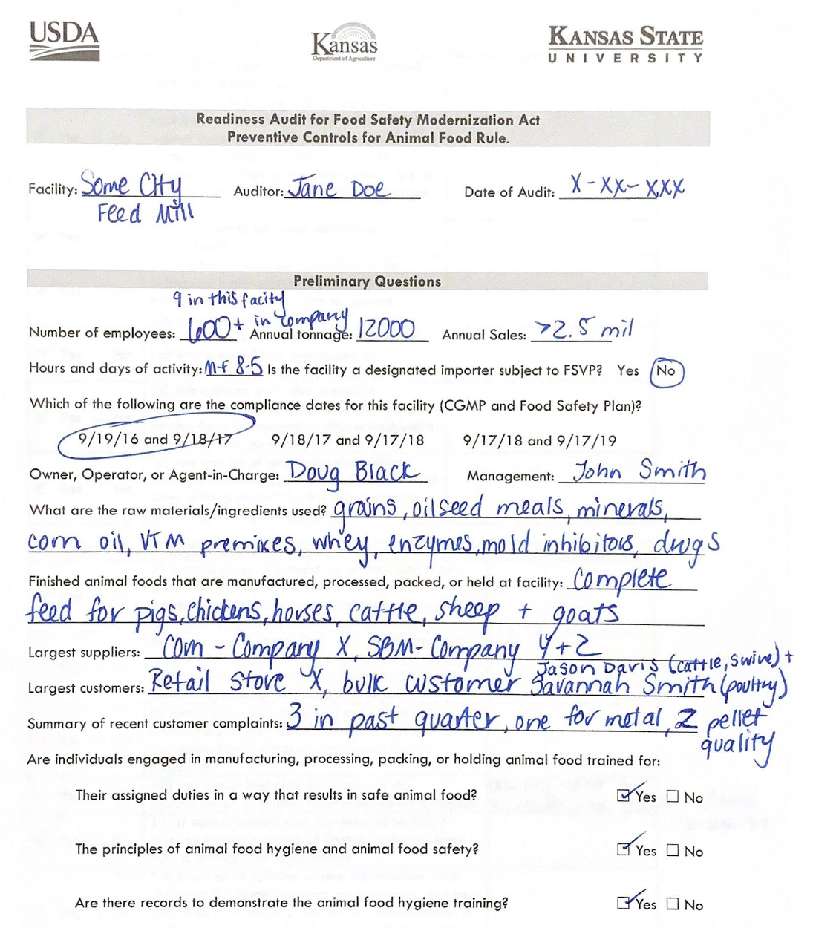

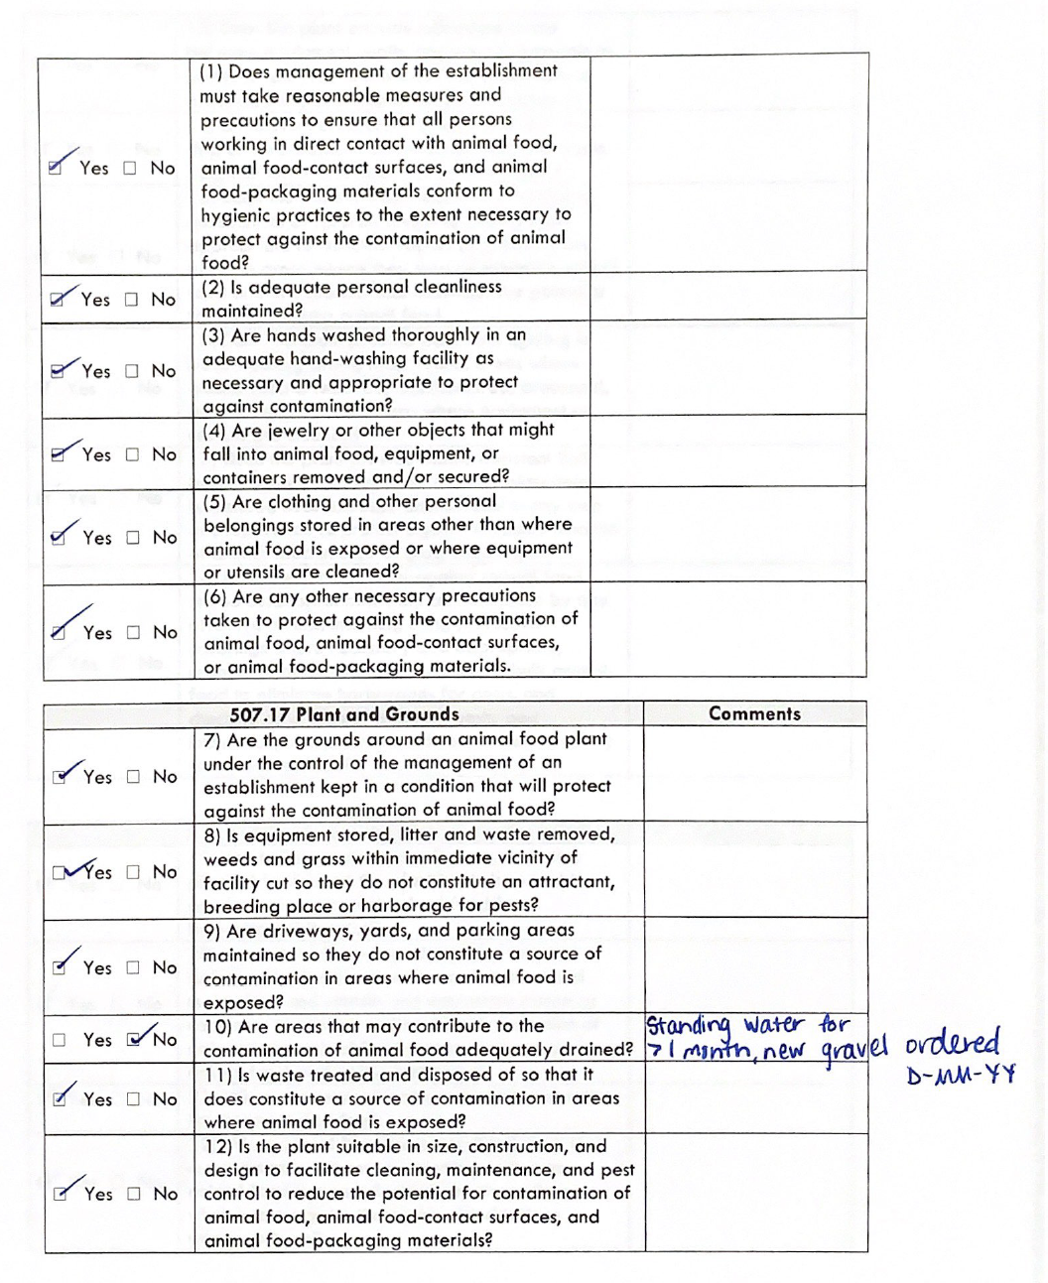

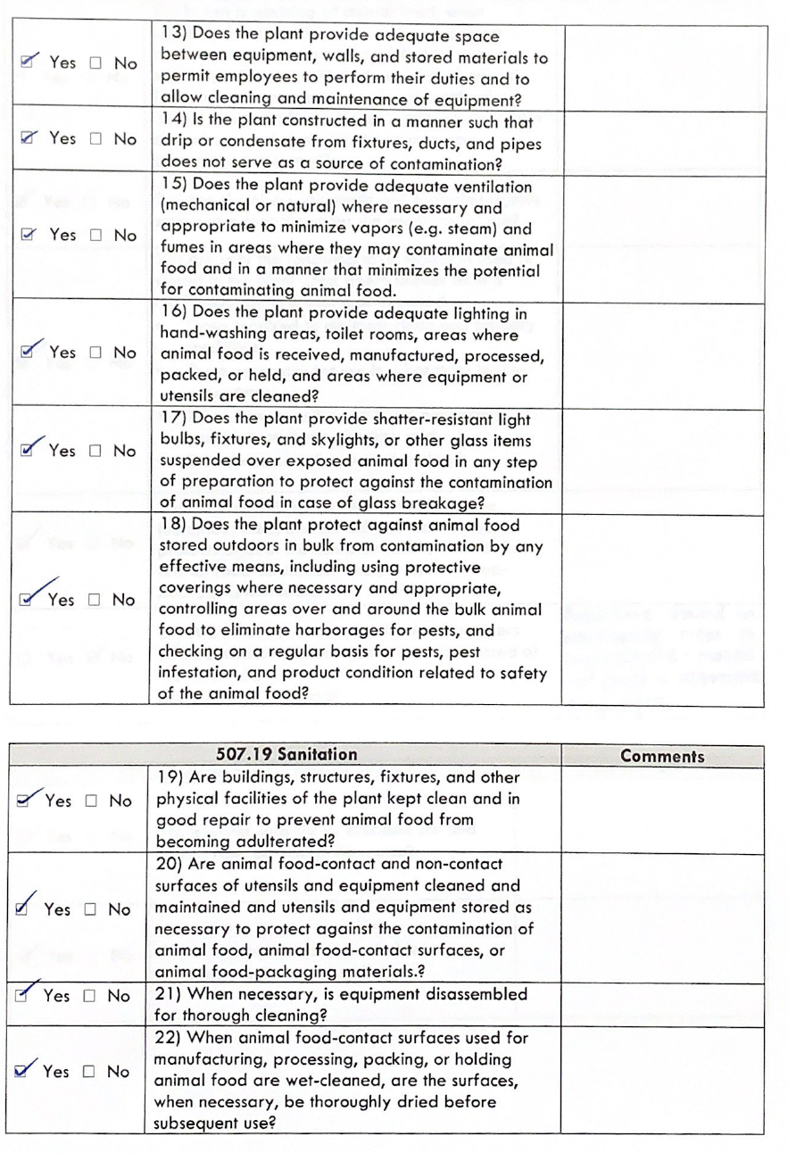
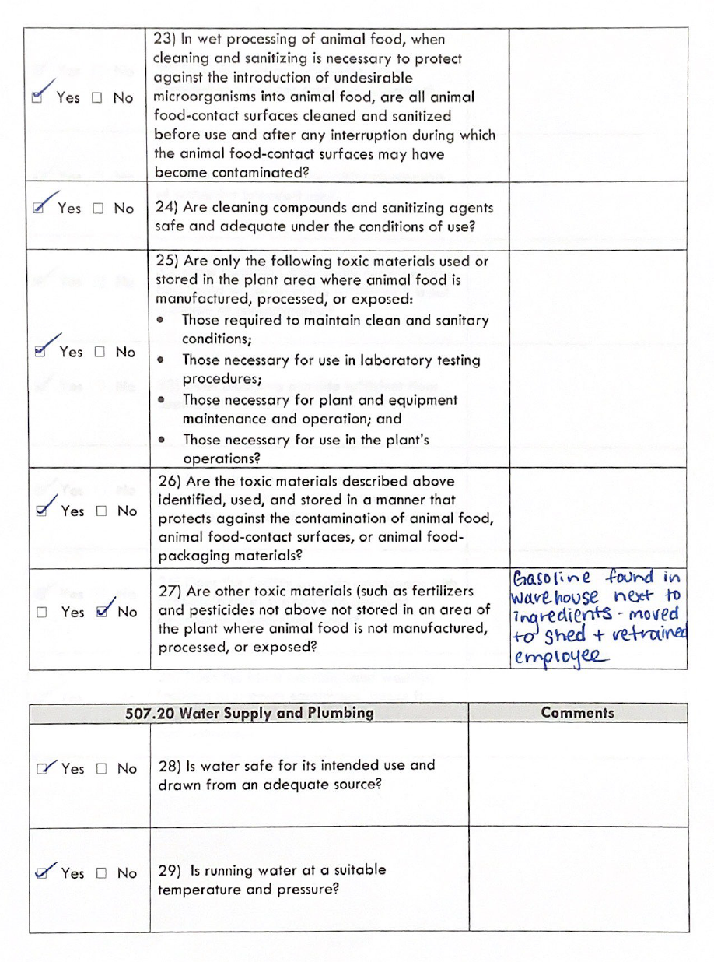

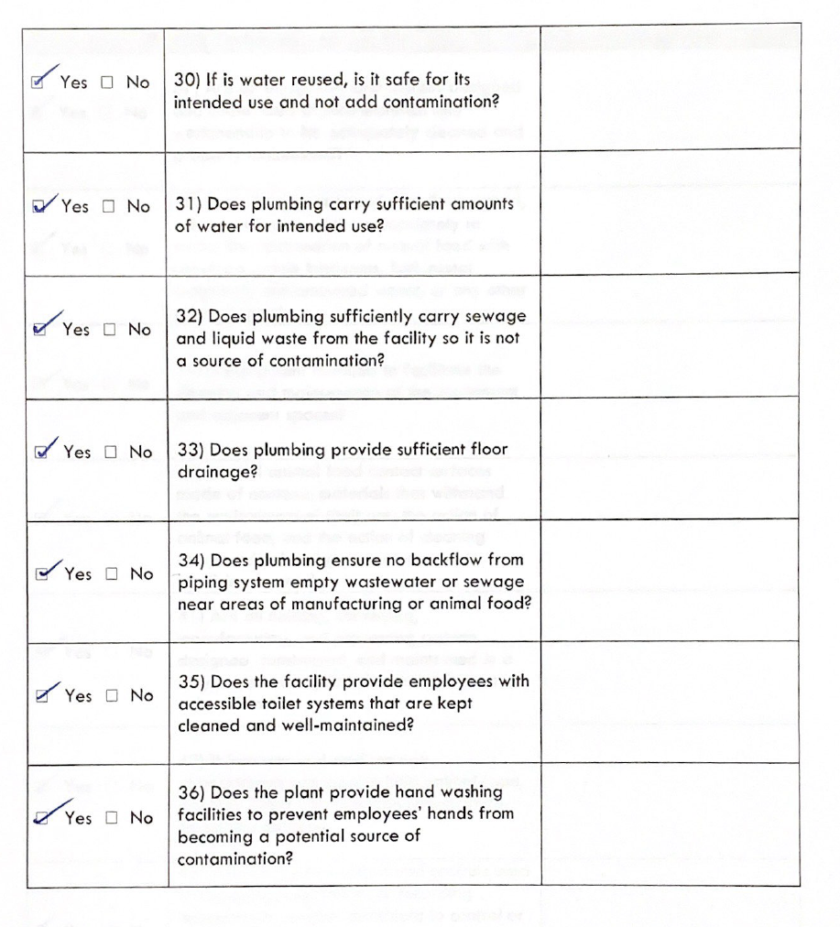

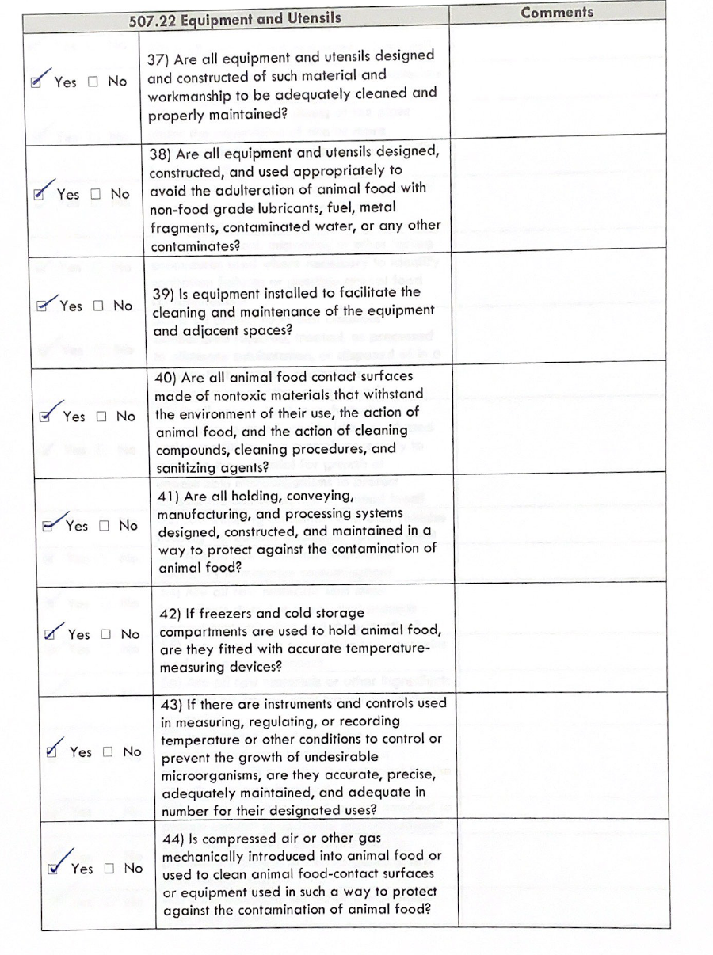

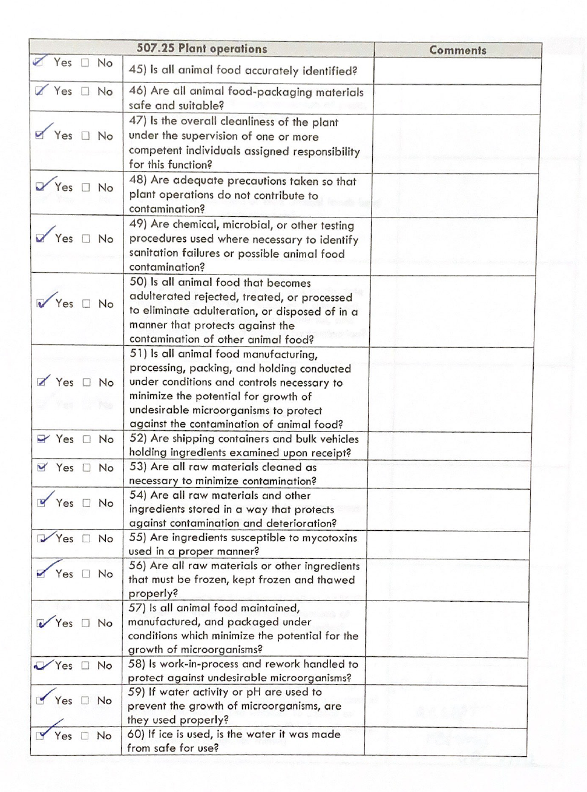

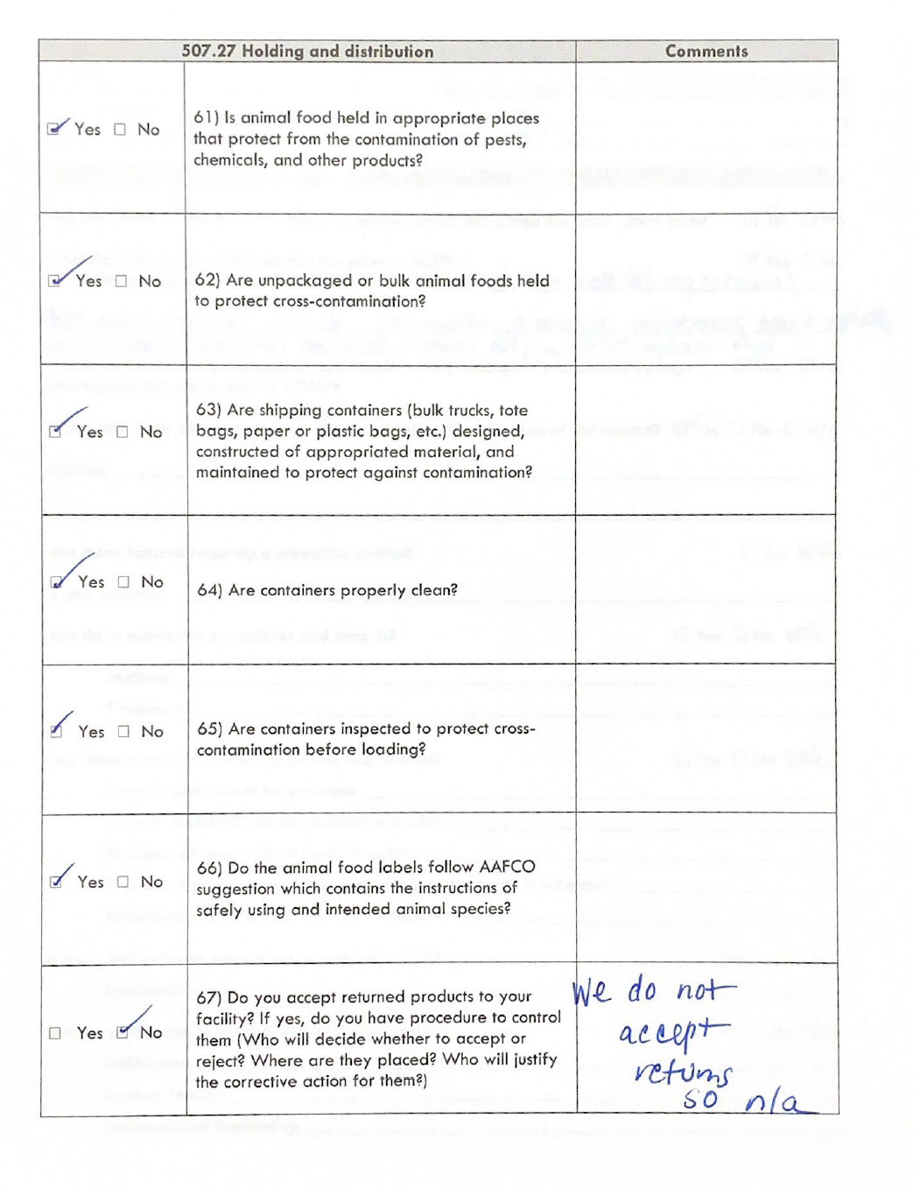

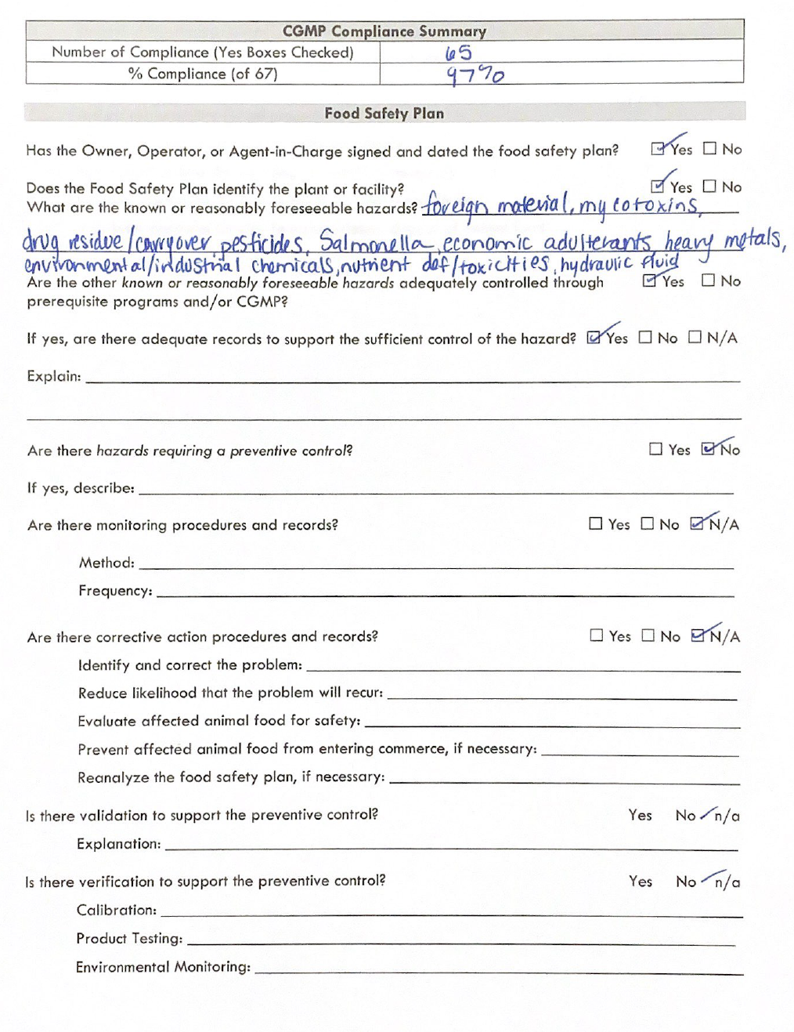

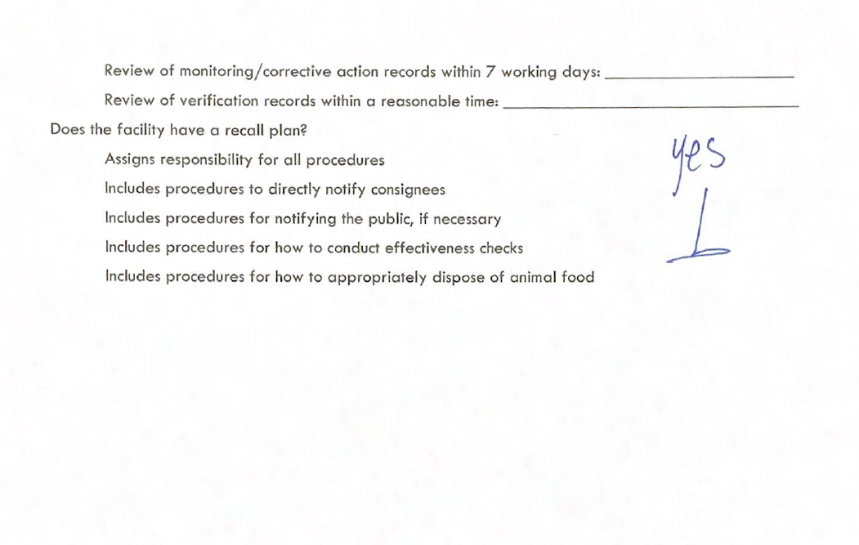

Appendix D: Hazard Analysis Justification

1. Mycotoxin Control Prerequisite Program for aflatoxin and fumonisin in corn and corn co-products and deoxynilvalenol (DON)/vomitoxin in wheat and wheat co-products

Stage 1 Strategy ⌂
Geographical-Based Risk Assessment Plan
Weekly third party surveillance reports of grain grown in various geographical locations will be reviewed, and used to develop the risk level of ingredient that is known to be sourced from a specific geographic region. If the weekly surveillance shows limited prevalence, then no further action is necessary.

Stage 2 Strategy ⌂
General Daily Composite Plan
If the geographic source location of ingredient is not known, or from an area where the risk assessment suggested moderate risk, additional surveillance will be developed to complete a General Daily Composite Plan. Daily composite is built at the scale house and tested once per day and recorded. Once per week these data are rolled up into a weekly weighted average. The weekly weighted average indicator is used to make decisions regarding mycotoxin strategy. If the weekly composite number is below 20 ppb for aflatoxin, 5 ppm fumonisin, and 5 ppm DON, then no further action is necessary.

Stage 3 Strategy ⌂
Composite by Supplier Plan
If weekly results generated during Strategy 2 are above threshold levels listed, then additional surveillance must be put in place to identify and mitigate the source of the mycotoxin. A daily composite for each corn, wheat, and co-product supplier is built at the scale house and tested once per day and recorded. Once per week these data are summarized into weekly weighted averages by supplier. The weekly weighted average by supplier indicator is used to make decisions regarding mycotoxin strategy. Suppliers identified as having mycotoxin levels above the threshold levels listed in Stage 2 but below 300 ppb for aflatoxin, 60 ppm fumonisin, and 10 ppm DON will be either sent to another feed mill for use in feeds for finishing beef cattle or have their ingredient segregated at the feed mill into bins specifically used for finishing beef cattle. In this case, the problematic ingredient cannot exceed 30% of the finished diet.

Stage 4 Strategy ⌂
High Aflatoxin Corn Supplier Mitigation Plan
If weekly composite results generated for an individual supplier are consistently above threshold levels listed in Stage 3, then additional mitigation steps will be employed to reduce the risk of accepting high mycotoxin corn. These steps can include, but are not limited to, movement of specific supplier corn to other destinations of less risk, cleaning, more intensive segregation strategies, consultation with regulatory authorities, or rejection of high threshold loads.

2. FDA Annual Pesticide Report, 2018
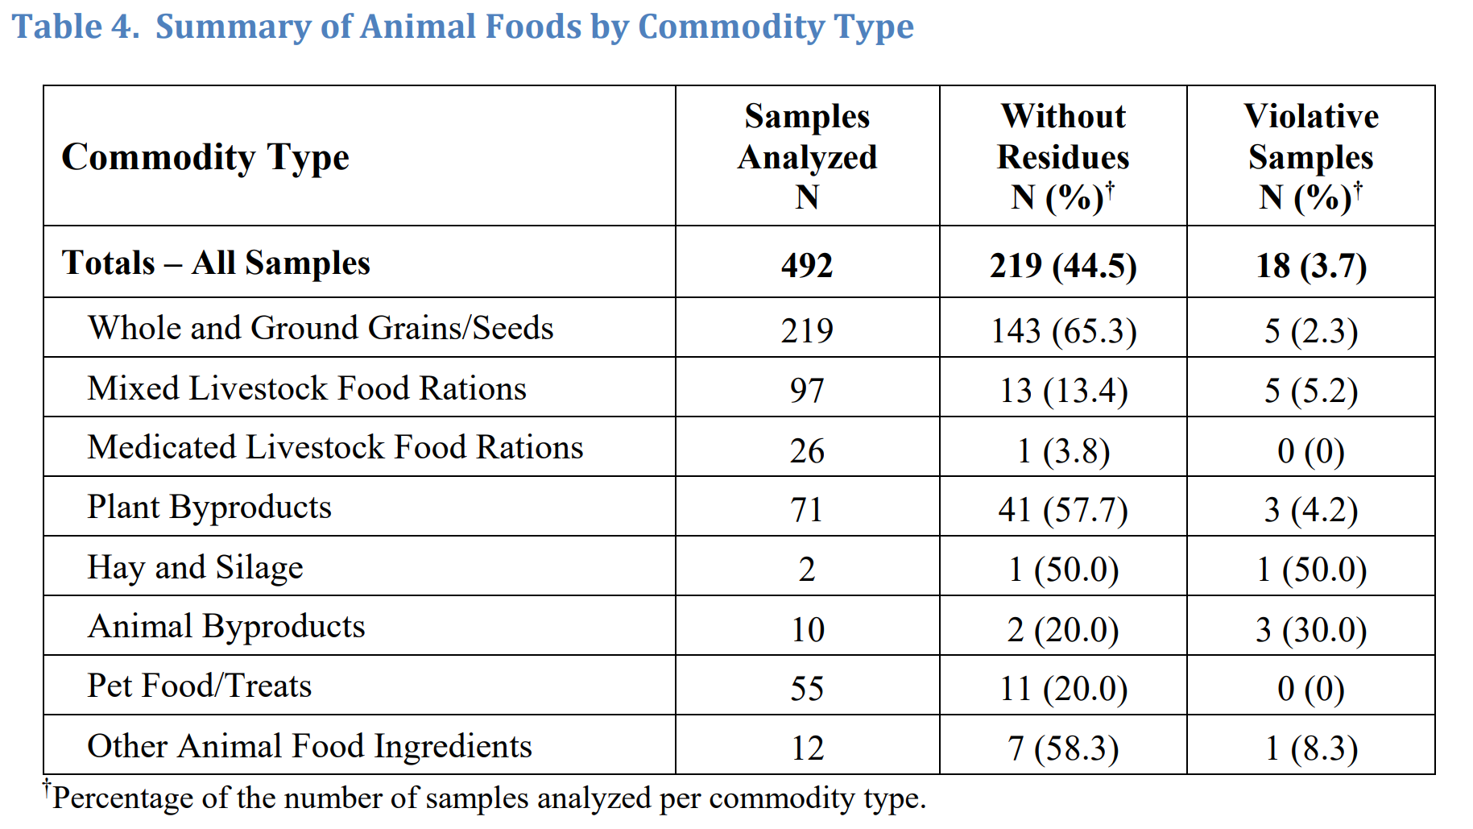

3. FDA Compliance Policy Guide Sec. 690.800 Salmonella in Food for Animals
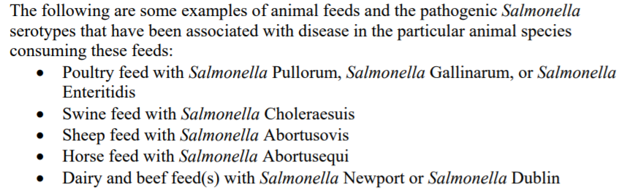

4. Li et al., 2012. Surveillance of Salmonella Prevalence in Animal Feeds and Characterization of the Salmonella Isolates by Serotyping and Antimicrobial Susceptibility. Foodborne Path. Dis. 9(8):692-298.
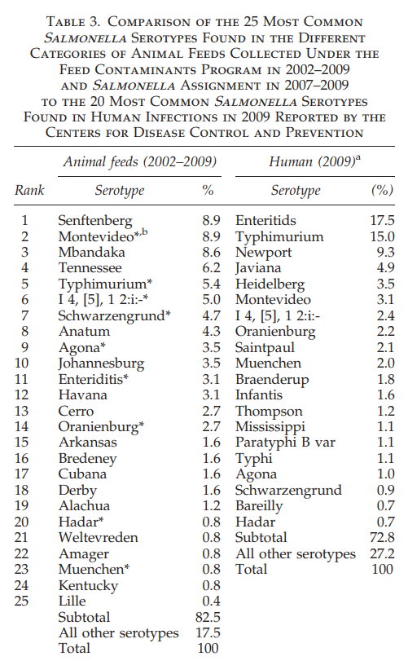

5. FDA Report of FY 2010 Nationwide Survey of Distillers Products for Antibiotic Residues
