DO ALL
YOU ‘CAN’
Support your neighbors in need and make a donation to the
Neighbor to Neighbor statewide food drive
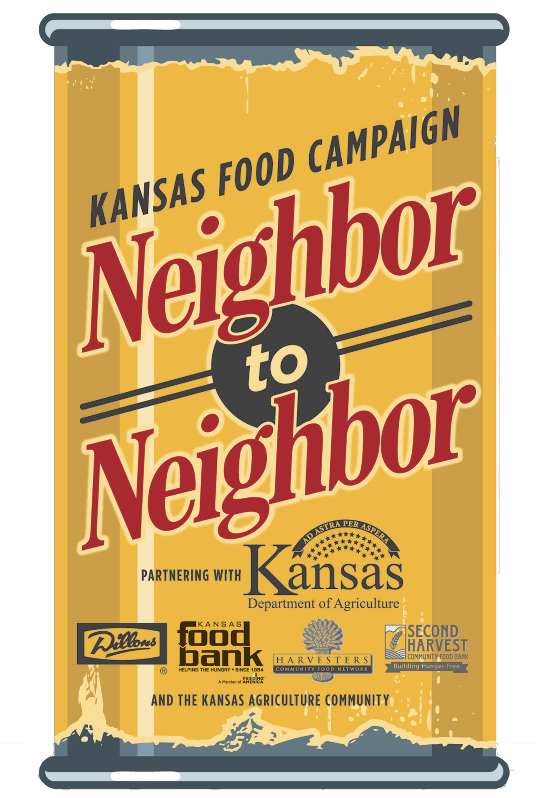March 3 - 25, 2014

{Local Food Drive Location(s)}
{Provide details for where community members can contribute to the Neighbor to Neighbor food drive.}

