KANSAS AGRICULTURE WEEK
March 23 - 29, 2014

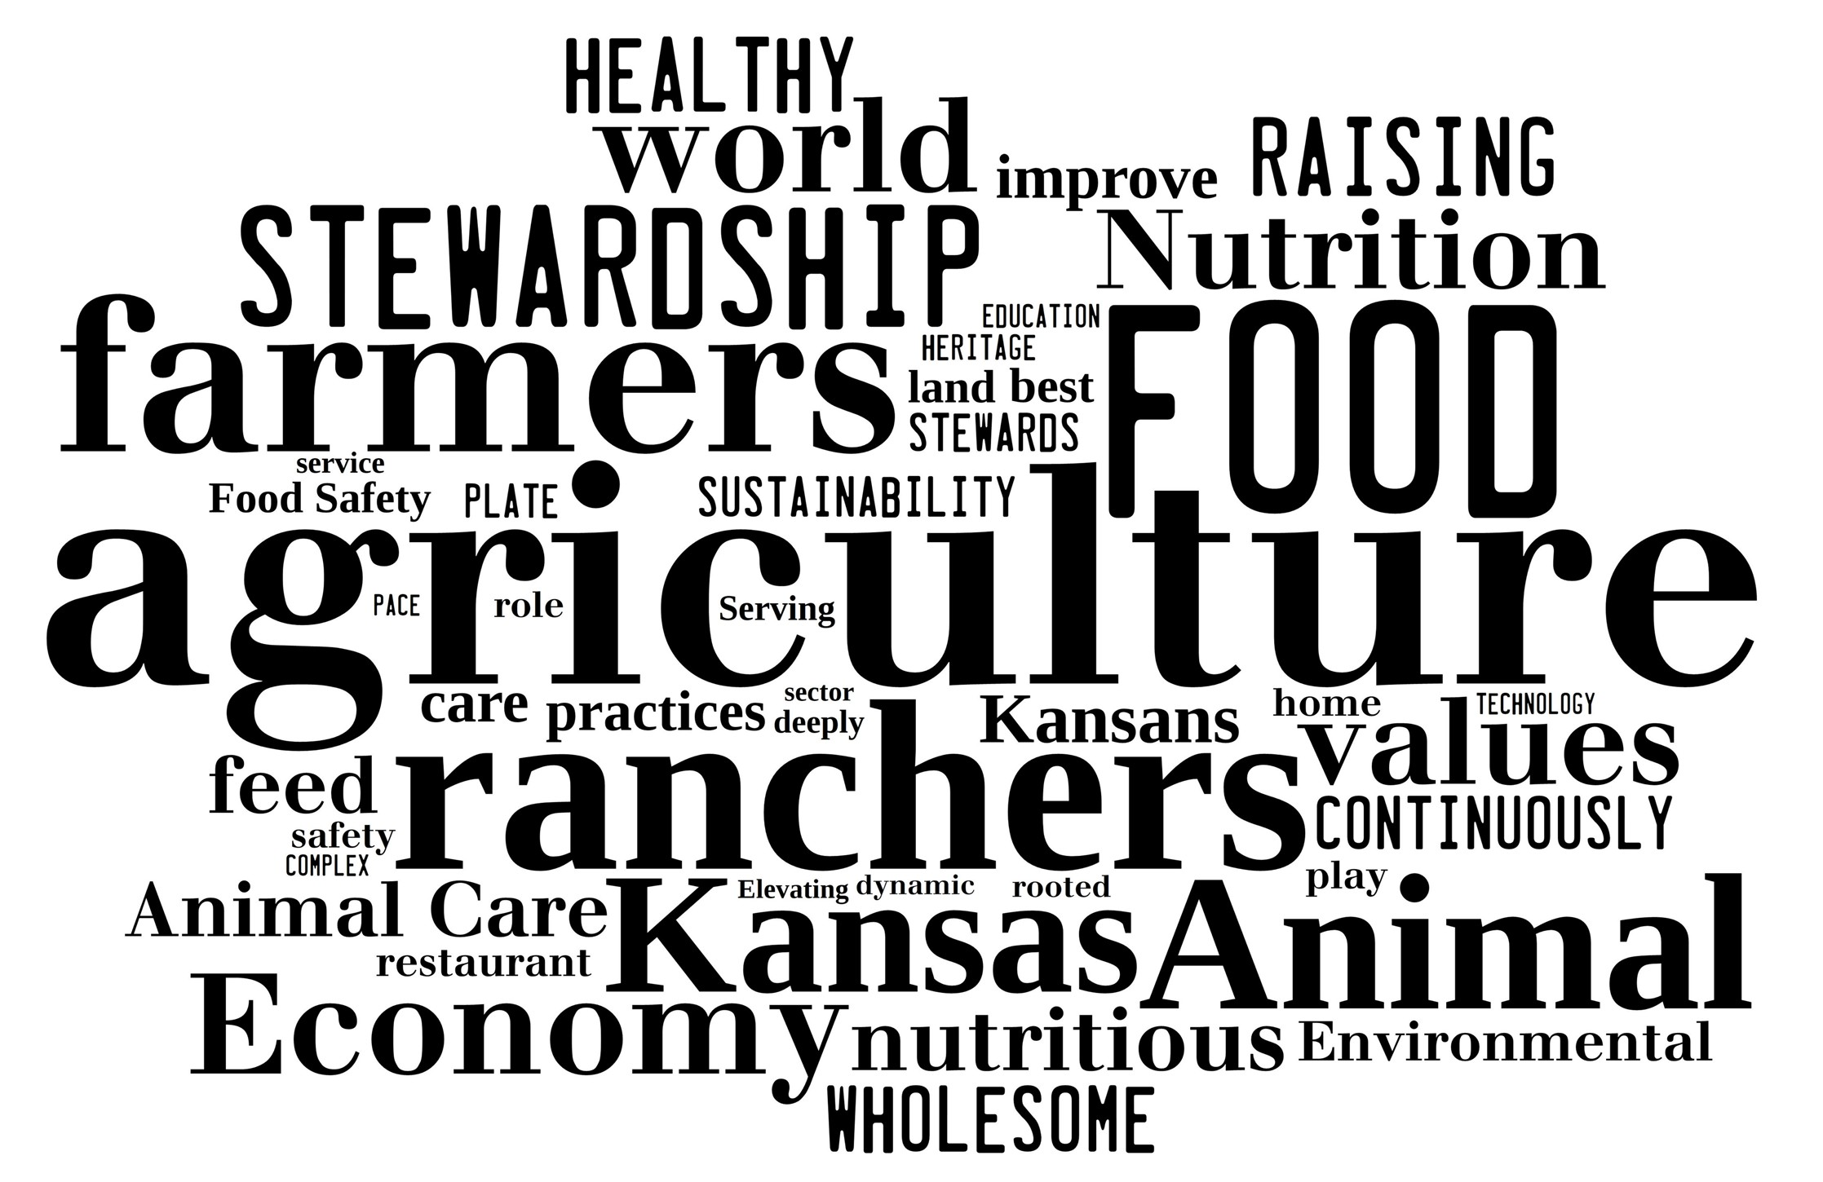

{Title of Local Celebration}
{Use this space to invite community members to your local Ag Day or Ag Week celebrations. Include details and links to pertinent information.}

